Patient Information System

Project Report

Submitted By:-



Integrated Systems

Submitted On: 20th May 2005

Table OF Contents

1 Project Name 2
2 Client 2
3 Client Introduction 2
4 Organization Structure 2
5 Objectives 3
6 Problem Statement and Description 3
7 Scope 4
Process Model 5
3.1 Overview 7
Requirements Specification 11
1 INTRODUCTION 12
1.1 Purpose: 12
1.2 Scope: 12
2 GENERAL DESCRIPTION 12
2.1 Product perspective: 12
2.2 User characteristics: 12
2.3 General constraints: 12
3 Functional Requirements 13
3.1 User Authentication: 13
3.2 General OPD Management 13
3.3 Specialist OPD Management 13
3.4 Admitted Patients Management 13
3.5 Admitted Patient Intake Chart 13
3.6 Admitted Patient Output chart: 13
3.7 Admitted patient daily Report: 14
3.8 Admitted patient Discharge Report: 14
3.9 Patient History Information: 14
3.10 Patient Operation information: 14
3.11 Patient test information: 14
3.12 Patient Death Report: 15
3.13 Wards information: 15
4 Non Functional Requirements 15
4.1 Legal: 15
4.2 Portability: 15
4.3 Security: 15
4.4 Tools and Technology: 15
4.5 User Friendliness: 16
4.6 Maintainability: 16
4.7 Communicativeness: 16
4.7.1 Process approval: 16
4.8 Errors and error messages: 16
4.8.1 Multilingual: 16
4.8.2 Help: 16
4.8.3 Software process: 16
4.9 Operability: 16
4.9.1 User interaction: 16
4.10 Training: 17
4.10.1 Level of training: 17
4.10.2 Time frame: 17
4.10.2 Help: 17
4.10.3 Traceability: 17
4.11 Storage Efficiency: 17
4.11.1 Location of data: 17
4.11.2 Database size: 17
4.12 Error Tolerance: 17
4.12.1 System behavior: 17
4.12.2 Simplicity: 18
4.12.3 Documentation: 18
4.12.4 Hardware Requirements: 18
4.13 Quality Attributes: 18
Data Flow Diagram (DFD) 19
Purpose 24
Scope 24
Definition, Abbreviations 24
GENERAL DESCRIPTION 24
Product perspective 24
User characteristics 24
General constraints 25
Level 3 SRS 25
Generate Slip 25
Minor Opd 25
Major Opd 25
Patient Test 26
Patient Admission 26
Generate tests report 26
Minor Opd report 27
Daily Activity 27
Pat Temp_BP Report 28
Pat intake 28
Use Cases 31
Expanded Use Cases 38
UC-1 Generate OPD Slip
UC-2 Patient Admission
UC-3 Daily Activity
UC-4 Patient Test
UC-5 Patient Operation
UC-6 Patient Dis charge
UC-7 Patient Death
Expanded Use Cases 38
Typical Course of Events 38
Typical Course of Events 40
Typical Course of Events 41
Typical Course of Events 42
Typical Course of Events 43
Typical Course of Events 44
Typical Course of Events 45
Domain Model 46
Concept Category List 48
Applying the Associations Checklist 49

System Sequence Diagram 51

SSD1 Startup
SSD2 Login
CO-1 Display_Login_Form()
CO-2 Login()
SSD3 LogOut
CO-3 LogOut()
SSD4 Record Patient Information
CO-4 Display_Patient_Info_Form()
CO-5 PatientInfo()
SSD5 Generate OPD Slip
CO-6 Patient_Info ()
SSD6 Patient Admission
CO-7 Admission_Form ()
CO-8 Ward_Info()
CO-9 Patient_Info()
CO-10 C/O()
SSD7 Generate Daily Report
CO-11 Patient_Info()
CO-12 Comment()
SSD8 Patient Intake Chart
CO-13 Patient_Info()
SSD9 Patient Outtake Chart
CO-14 Patient_Info()
SSD10 Patient Test
CO-15 Patient_Test_Form()
CO-16 Patient_Info()
CO-17 TestInfo()
CO-18 Date()
CO-19 Advised_Doctor()
SSD11 Patient Operation
CO-20 Operation_Form()
CO-21 Patient_Info()
CO-22 Operation_Theater()
CO-23 Date()
CO-24 Advised_Doctor()
SSD12 Patient Discharge
CO-25 Discharge_Form()
CO-26 Patient_Info()
CO-27 Date()
SSD13 Patient Death Certificate
CO-28 Death_Certificate_Form()
CO-29 Patient_Info()
CO-30 Date()
CO-31 DoctorInfo()
SSD14 Examine Patient Record
CO-32 Patient_Record_Form()
CO-33 Patient_Info()

Contract Diagram
CD-01 LOGIN 102
CD-02 Patient Information 102
CD-03 OPD Slip 103
CD-04 Patient Admission 103
CD-05 Daily Report 103
CD-06 Intake Chart 104
CD-07 out take Chart 104
CD-08 Patient Test 105
Class Diagram 108

Project Proposal

Project Name

Patient Information System

Client

Khyber Teaching Hospital Peshawar

Client Introduction

Khyber Teaching Hospital and allied institutes is an autonomous body created under Medical and Health institution reform act 1999. It comprises of three institutes namely Khyber Teaching Hospital, Khyber Medical College and Khyber College of Dentistry. The control and management of autonomous body is rested on the management committee of the institutions. The management committee comprises of Chief Executive, Medical Superintendent, Director Finance, Principals of KMC & KCD with three Non- officio members.

4 Organization Structure
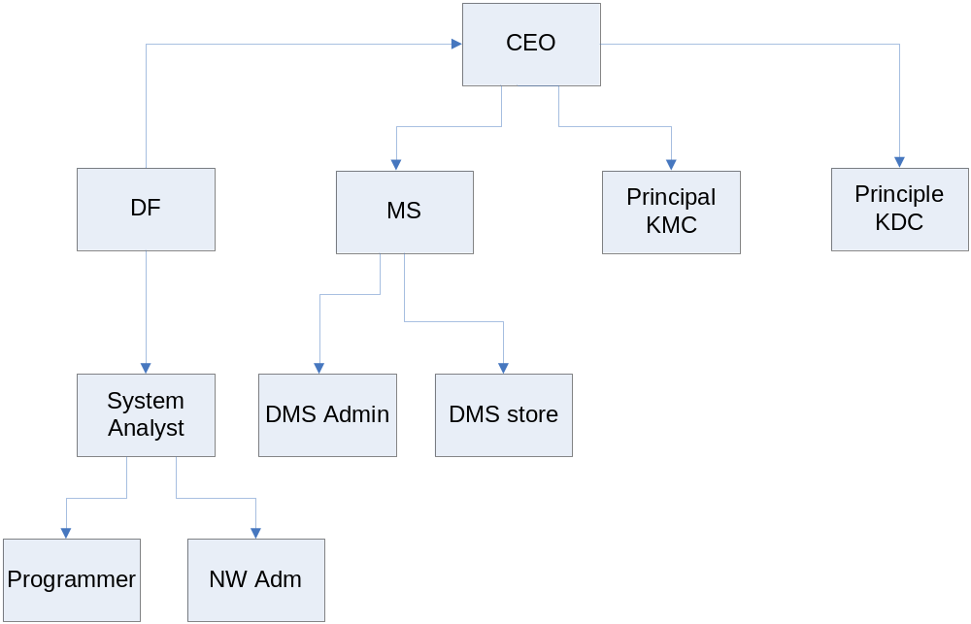

5 Objectives
Our main objectives for this project are as follows:
- Learn main Concepts of Software Engineering
- Implementation of these concepts.
- Remove manual handwork system and provide complete automated system to the Hospital.
- Provide best facility to keep track of Information and Management in statistical analysis.
- Analyze the proper growth and needs of the Hospital.

6 Problem Statement and Description
The purpose of choosing this project is to fulfill our course requirements. We took this project as we have strong concepts and background of Database systems. This project is easy to understand as we are fully aware of the hospital environment. The major problem address by the project is as follows.

TOO MANY REGISTERS: There are a lot of registers used in maintaining the data. These registers are very difficult to maintain.

DATA REDUNDENCY: By studying the manual data stores it can be seen that there is a high degree of data redundancy. Same data is stored in too many registers redundantly.

BURDON OF WORK: The duplication of work has increased the over all burden of work.

CHANCES OF MISTAKES Due to the burden of work, there are more chances of mistakes in recording data in registers.

UNAVAILABILITY OF INFORMATION: Unavailability of information is the result of inconsistency in retrieving the desired data and due to the fact that no proper information system is present.

INCONSISTENCY: The use of the large number of bulky registers for tracing of a particular record is not only wastage of time but also causes inconsistency in data.

UNAVAILABILITY OF INFORMATION: Unavailability of information is the result of inconsistency in retrieving the desired data and due to the fact that no proper information system is present.

ABSENCE OF COMMUNICATIN BETWEEN WARDS: There is no communication link between wards so information cannot be exchanged between them in the current system.

LOSS OF PATIENT DATA: Due to recording patient information in large number of bulky registers patient data can be lost as registers can tear out or damage.

7 Scope
The major scoop of the project which emphasizes our project is as follows.
- Keep track of all Patients that visit OPD.
- Keep track of all admitted patients in different wards.
- Keep track of various activities that are performed in wards on daily basis. (Temperature checking, blood pressure checking, intake of Patient, output of Patient.
- Keep track of daily operations performed in Operation Theater.
- Keep track of patient history.

Process Model

Requirements

The following requirements were suggested by the customer and our own observations.
- How many patients visit the OPD on a specific date?
- How many patients from a specific district?
- How many patients are admitted in a ward on a specific date?
- How many beds are occupied in a ward?
- How many beds are empty in a ward?
- Keeping track of admitted patient information?
- How many patients are operated on a specific date?
- Who operate a specific patient?
- How many patients are discharged on a specific date?
- What is the status of the discharged patient?
- Schedule of the daily OPD.
- Keeping information about the various tests that were conducted for a patient.
- Who advised the tests for a patient?
- How many OPDs are there in hospital?
- Admitted patient daily temperature and blood pressure report.
- Keeping patient history information.
- Providing online information about the admitted patients i.e. their ward, bed# etc.

Selection Criteria

The following points were considered for the selected of a process model.
- Requirements and change frequency of requirements.
- Customer Availability.
- Nature of the Project
- Method and tools to be used
- Controls and Deliverables that are required
- Time
- Team size
- Our level of understanding of the tools and technology.
- User’s level.
- To make a prototype or a complete project
- Documentations

Process Model

We have chooses the “Waterfall Lifecycle Model” in development of our project.

Overview
The waterfall model is an activity centered model that prescribes a sequential execution of a subset of the development and management processes involved in the project. Figure 1 is an overview of the different phases of the model that we will follow:

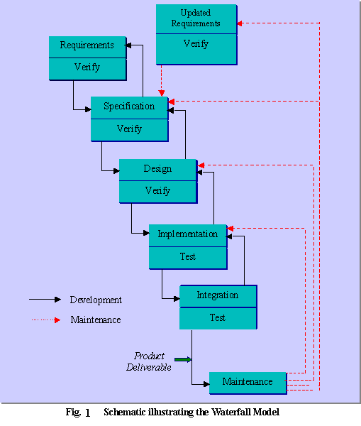

3.2 Justifications
The following justifications are quoted which opt in choosing this process model.

3.2.1 Matured System
The waterfall lifecycle model is the most straightforward and controlled of all the models. It is most feasible in the situations where a well-established manual system already exists, and the requirements are well-understood, which is true in our case. Khyber Teaching Hospital has predefined and mature requirements. The manual system is running with same policies from several years, so we follow the same traditions in designing the problem (project). Waterfall model views software development as a series of processes that are expected to be done only once for the project, i.e. they are to be done in the proper order. So detail requirements, clarifications from the customer and judgment by detail study in understanding the system is well proved by the customer and other feedbacks as well.

    - Inherent Testing
Testing is inherent to every phase of the waterfall model. At the end of each phase it is verified to minimize the error. Figure 1 shows the complete verification and testing visual representation after each step.

    - Documentation Driven
It is documentation driven, that is, documentation is produced at every stage. It helps us and customer to get up-to-date with the project work. Customer gets full interaction with the project as he can study the documentation which is done after each phase. Our customer is mainly available in Peshawar, so it helps him to get review the document online which saves his time.

    - One Time Requirement
One time requirement is one limitation of this model. This freezes the requirement which may be drawback in other cases. In our case the requirements are well matured and manual system is already implemented in the hospital. As it is running from years, so no frequent changes are required in designing the project requirements. So it causes us to get the requirement only once which is the plus point for us and the customer as he was in Peshawar.

    - Simple and Discipline Approach
Waterfall process Model is an enforced disciplined approach. Step by Step approach which is normally followed in predefined requirements.

    - Risk Reduction through Prototyping
Risk reduction is minimized by showing the prototype model of the problem. As our customer can’t be available for most of time, so we decided to show him a prototype at start of the project. Prototype is a showcase model which helps customer in understanding what may be outlet of the problem. Appropriate visual requirements are clarified. By showing prototype model, customer is self satisfied and properly understands what he will be getting the output from the project. Secondly prototyping will be also helpful for visual improvements and GUI which makes the project user friendly and easy to operate. As hospital staff has to operate the system, so we try our best to make things simple. Another case may be as requirements can’t be change, so defined requirements can be finalized by all approved changes in the prototype which reduce risk reduction. Drawback for using prototype is the duplications of effort and cost but customer is willing to manage it for all the effort.

    - Customer Communication
Waterfall model helps in customer communication. As documentation is done after each phase so it might help the customer to communicate and interact through documentation. It will save customer time and he need not to evaluate the progress of the project by coming again and again to out software company. At start of the project we show the customer the prototype from where he judges the outlet of the final project. Then as the phases goes on he will be getting the documentation after each phase and if he has any queries he can contact through mail or by phone. This will be more flexible way of communicating each other.

    - Sequential-Linear Process Model
The basic sequential approach we will use will be as follows.

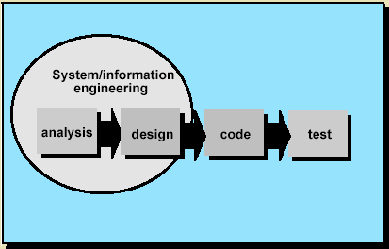
This is the simplest approach we will be using which suits the nature of the customer.

- Alternatives
In case, we find at some later stage that the chosen model does not work in our case, I think it would be best to adapt the Incremental model as an alternative, because it is most similar to the Waterfall model and we will be able to make a transition with only a little modification and effort. In this case we would be able to review our whole development life cycle multiple times and will get the opportunity to fix any anomalies, hence refining our product. In this case, the product would be handed over to the users, after each phase (or increment), and the feedback coming from the users would be guiding us during the next phase of the project life cycle. So proposed alternative models are
- Incremental Model
- XP Model
XP model because as it is used mostly nowadays so we may opt for it as well.

Requirements Specification

INTRODUCTION

Purpose:
The purpose of this application is to automate the patient information system. This would eliminate the ongoing lengthy paper works and thereby making these processes less time consuming and efficient. This application will help the management to have statistical analysis for their future decisions.

Scope:
This is client server application where the server will be located at a central position and different clients will access the server from different location like OPD, WARDS, and PATHOLOGY DEPTT etc. Users can sign in, giving ID and password. The accessibility will vary depending on the users.

GENERAL DESCRIPTION

Product perspective:
This software will contain patient personal information, patient history information, patient disease information, patient tests information, wards information, occupied beds and empty beds in ward information, discharge patients information and patient death information.

User characteristics:
The database management system is targeted towards all the employees of Khyber Teaching Hospital - Peshawar. This includes CE, MS, DMS, System Analyst, OPD In charge, Medical Faculty and other concerned employees. Each of them will be able to access this software from the Hospital Intranet.

General constraints:
This report should maintain a balance between the formats specified by the client.

Functional Requirements

User Authentication:
    - Users are divided into different groups.
- Data Entry Operator
- Medical Faculty
- System Analyst (Administrator)
    - System should provide each group member with User Id and password which can be access anywhere from the intranet of the hospital.
    - Each Group Member is given different authorization depending upon his requirements.

General OPD Management
    - System should record patient information i.e. patient # and patient name.
    - System should keep record of the doctor who treated the patient.
    - System should keep record of all the medicines advised by the doctor and various test.

Specialist OPD Management
    - System should record information about the referring OPD.
    - System should record information about the referring doctor.
    - System should keep record of the various medicines advised by the doctor and various test.

Admitted Patients Management
3.4.1 System should record complete information about the patient, referring OPD information, referring doctor information, date of admission.

Admitted Patient Intake Chart
    - System should provide a complete report specifying patient information, advised medicines, route of the medicine, its date and the quantity of the medicine.

Admitted Patient Output chart:
    - System should provide daily information about the vomiting, stool, urine of the patient.
    - System should also provide a complete report that gives information about the patient daily output with time.
    - System should generate printed copy of the report.

Admitted patient daily Report:
    - System should provide a daily report that contains patient information, patient temperature information, patient blood pressure information and any complaint that patient has about his health is needed.

Admitted patient Discharge Report:
    - The system should generate a discharge report that contains complete patient information.
    - The discharge report must provide information about the medicines that were advised by the doctor to patient for home treatment.
    - Discharge report should provide information about the doctor who decided to discharge the patient.
    - System should generate printed copy of the discharge report.

Patient History Information:
The system must maintain/provide information about.
    - Patient family history.
    - Patient past history.
    - Various diseases of the patient.
    - Various medicines the patient has used till now.

Patient Operation information:
System should provide the following information.
    - Information about the operation process.
    - Information like who operated the patient, the date of operation, the assistants that assist the doctor during the operation.
    - The end result of the operation.

Patient test information:
    - System should provide information about the test like test name, test type and cost.
    - The test result of the test.

Patient Death Report:
    - The medical faculty also needs to store information about the patients who get expired during their treatment.
    - System should provide the report contains information about the patient, the ward in which the patient was admitted, the date patient was get expired and the admission mod information.

Wards information:
System should provide following information about the wards.
    - Information about the different wards in the hospital.
    - Information about the capacity of each ward.

Non Functional Requirements

Legal:
The details of this project will not be shared with any other party other than the Employees of ‘Khyber Teaching Hospital Peshawar’.

Portability:
The software should work independent of the operating system. Preferred operating systems are Windows 2000/XP.

Security:
There are different access levels for different people corresponding to their seniority or as per specified by the CEO for exceptional cases.

Tools and Technology:
As there is a distributed system the database server is SQL server in order to have a powerful server

User Friendliness:
The interface should be user friendly as to minimize the probability of errors while viewing or entering data.

Maintainability:
The program and design should be visible as to make the maintenance easier.

Communicativeness:

Process approval:
After approval of requirements document, no additional requirements will be added unless Requirements change control process is followed.

Errors and error messages:
Descriptive error messages will be provided.

4.8.1 Multilingual:
The system will be in English.

Help:
The system will provide context sensitive help.

Software process:
The system will be based on the functional requirements, which are according to the business process, and will be approved by user.

Operability:

User interaction:
The users of the system should be familiar with the standard windows environment.

4.10 Training:

4.10.1 Level of training:
Little or no training is required for the new modules being developed as the current users of the system are well versed with how the system works.

Time frame:
Time frame for training should not exceed an hour.

Help:
Help will be provided with the system. In addition a user guide will also be provided.

Traceability:
All the requirements are traceable to business processes.

Storage Efficiency:

Location of data:
Data will be stored on a database server and clients will be attached to server. Data will be stored in database within the company LAN.

Database size:
Total number of records could go up to any number depending upon storage capacity, but the client will provide us the maximum number of database records so that he information can be incorporated in the requirements document and design.

Error Tolerance:

System behavior:
All errors will be trapped and conveyed to the user.

Simplicity:
System will be designed according to the workflow of the actual process and thus will be easy for the final users

Documentation:
Technical and user documentation will be provided with the system.

Hardware Requirements:
Pentium III 800 MHz
128 MB RAM

Quality Attributes:
The quality attributes which will be provided by the system will be as follows:
- Ease of use
- Reliability
- Security
- Performance
- Time saving
- Efficiency
- Maintenance.
- Auto Log Generator

Data Flow Diagram (DFD)

- Level 0 DFD
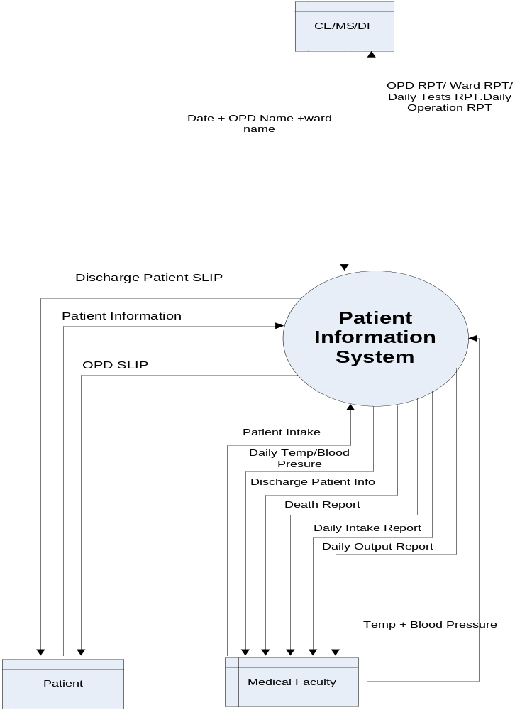

- Level 1 DFD

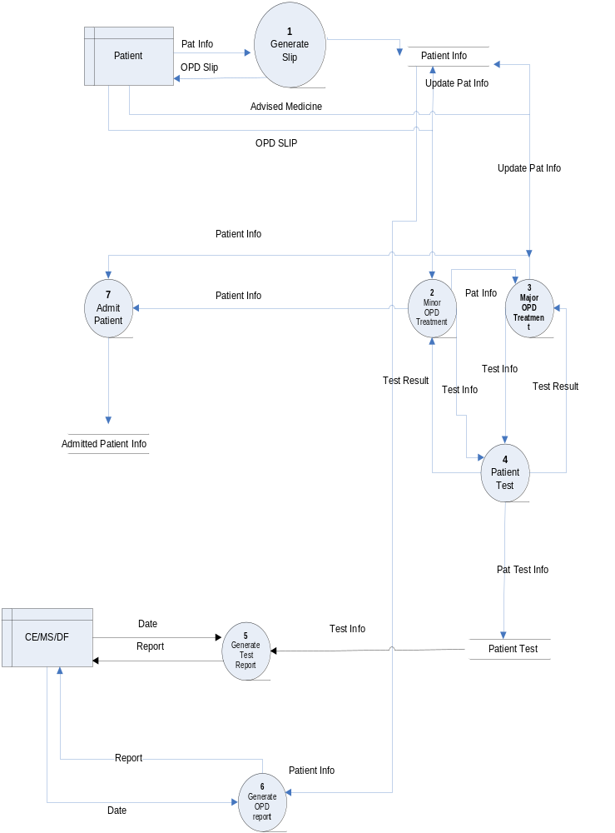
3) Level 2 DFD
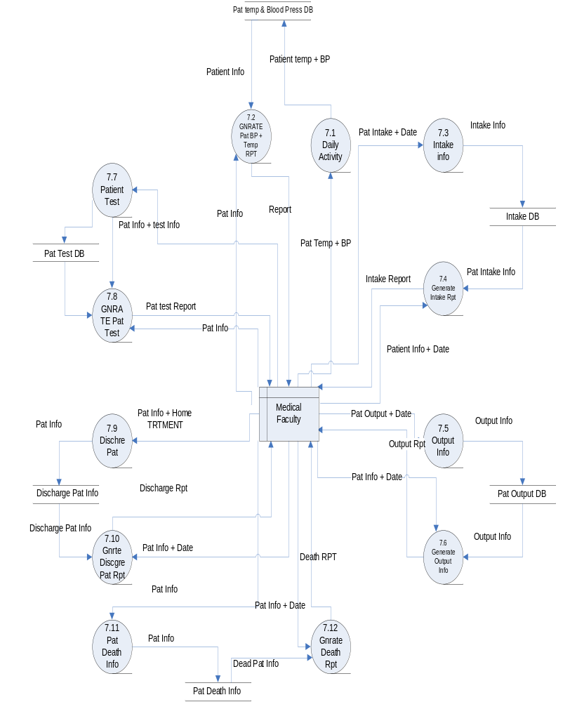

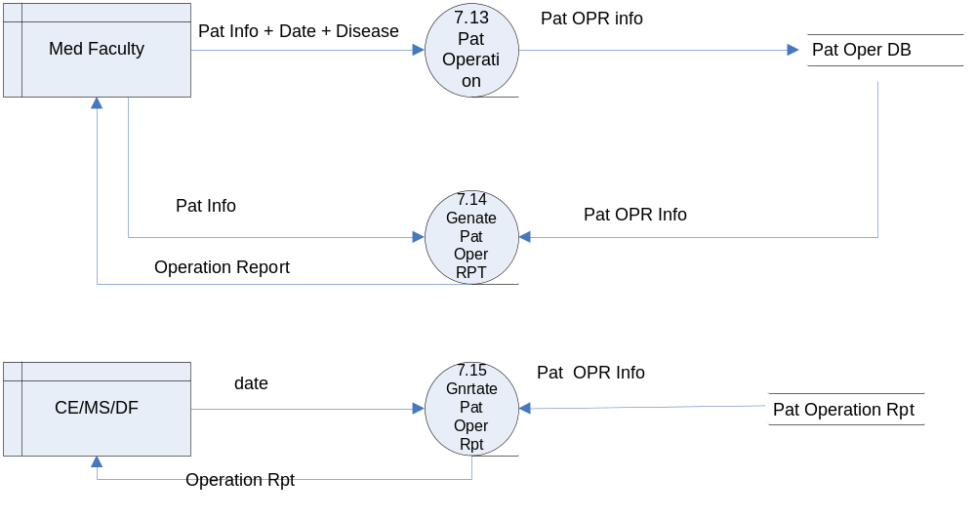

Purpose
The main purpose of this application is to automate patient information system and to provide statistical analysis facility to hospital management to make their future decisions efficiently. This would eliminate the ongoing lengthy paper works thereby making these processes less time consuming and efficient.

Scope
The patient information system is to be designed in such a way that it can be implemented on a LAN and everyone can have access to it from his computer. Users can sign in, giving ID and password. The accessibility will vary depending on the users. Technologies to be used for this purpose are VB.Net and SQL server for the back end database.

Definition, Abbreviations
CE: Chief Executive
MS: Medical Superintendent
DF: Director Finance

GENERAL DESCRIPTION

Product perspective
This software will keep record of all patients that visited OPDs that are admitted in wards, daily activities performed in wards, daily record of patient temperature and blood pressure information, daily patient intake information for patient status analysis, daily patient output information for patient status analysis, various test that are advised by medical faculty to the patient, information about the patients that are discharged and information about the patients that are expired.

Similarly all statistical analysis information like

- How many patients visited OPD on a specific date?
- How many patients are admitted in ward?
- How many tests are conducted on a specific date?
- How many wards are there in hospital?
- What is the capacity of each ward?
- Will be provided.

User characteristics
The database management system is targeted towards all the employees of Khyber Teaching Hospital. This includes CE, MS, DF and Medical Faculty. Each of them will be able to access this software from their PC’s.

General constraints
The report should maintain a balance between the format specified by the client and the supervisor (instructor).

Level 3 SRS

Function | Generate Slip
Description | Data entry operator generates OPD slip
Input | Patient#, Patient name.
Source | patient
Output | Printed Copy of OPD Slip
Destination | Patient
Requires | Patient Info
Pre- Condition | Data entry Operator should login
Post- Condition | - None
Side Effects | Nil

Function | Minor Opd
Description | Patient treatment in Minor treatment
Input | Patient#
Source | patient
Output | OPD Slip + Advised Medicines
Destination | Patient
Requires | Patient Info
Pre- Condition | Patient should have OPD Slip
Post- Condition | - None
Side Effects | Nil

Function | Major Opd
Description | Patient treatment in Major treatment
Input | Patient# + Referring OPD Information
Source | patient
Output | OPD Slip + Advised Medicines
Destination | Patient
Requires | Patient Info
Pre- Condition | Patient should have OPD Slip
Post- Condition | - None
Side Effects | Nil

Function | Patient Test
Description | Patient test result to find cause root of disease
Input | Patient# , test type, test name
Source | Minor OPD, Major OPD
Output | Test Result
Destination | Minor OPD, Major OPD
Requires | Patient OPD#, Test Type, Test Name
Pre- Condition | Patient should have OPD Slip , Referring OPD Ref
Post- Condition | Test type and test name matches available tests.
Side Effects | Nil

Function | Patient Admission
Description | Patient Admission in ward
Input | Patient# ,Name, Ward Name, Bed#,  Date of admission, age, sex
Source | Minor OPD or major OPD
Output | Ward Admission Slip
Destination | Medical faculty
Requires | Patient Info
Pre- Condition | Patient should have OPD Slip and reference of doctor who has admitted him.
Post- Condition | - None
Side Effects | Nil

Function | Generate tests report
Description | Provides total no of test carried out on a specific date
Input | date
Source | CE/MS/DF
Output | Printed copy specifying total no of test carried out on a specific date
Destination | CE/Ms/DF
Requires | Stored Patient tests information
Pre- Condition | Must have at least one patient test information
Post- Condition | - None
Side Effects | Nil

Function | Minor Opd report
Description | Provided information about total no of patients visited OPD on a specific date
Input | date ,OPD Name
Source | CE/MS/DF
Output | Printed copy specifying total no of patients visited OPD carried out on a specific date
Destination | CE/MS/DF
Requires | Stored patient opd information
Pre- Condition | At least one patient must visit opd
Post- Condition | - None
Side Effects | Nil

Function | Daily Activity
Description | Provided daily information about patient temperature and blood pressure.
Input | date ,Pat Temp, Pat BP
Source | Medical faculty
Output | Printed copy specifying patient temperature and BP on daily basis.
Destination | Medical faculty
Requires | Stored patient temp and BP information.
Pre- Condition | Patient temp and BP information
Post- Condition | - None
Side Effects | Nil

Function | Pat Temp_BP Report
Description | Provided information about patient temp and PB on a specific date
Input | date ,pat#
Source | Medical faculty
Output | Printed copy specifying patient information and patient temperature and BP on a specific date
Destination | Medical faculty
Requires | Patient admitted in ward
Pre- Condition | Patient temp and BP information
Post- Condition | - None
Side Effects | Nil

Function | Pat intake
Description | Provided information about daily patient intake
Input | date ,pat#,medicine,quantity,route
Source | Medical faculty
Output | Printed copy specifying patient information and patient temperature and BP on a specific date
Destination | Medical faculty
Requires | Patient admitted in ward
Pre- Condition | Advised medicines
Post- Condition | - None
Side Effects | Nil

Use Cases

Use Case Diagram

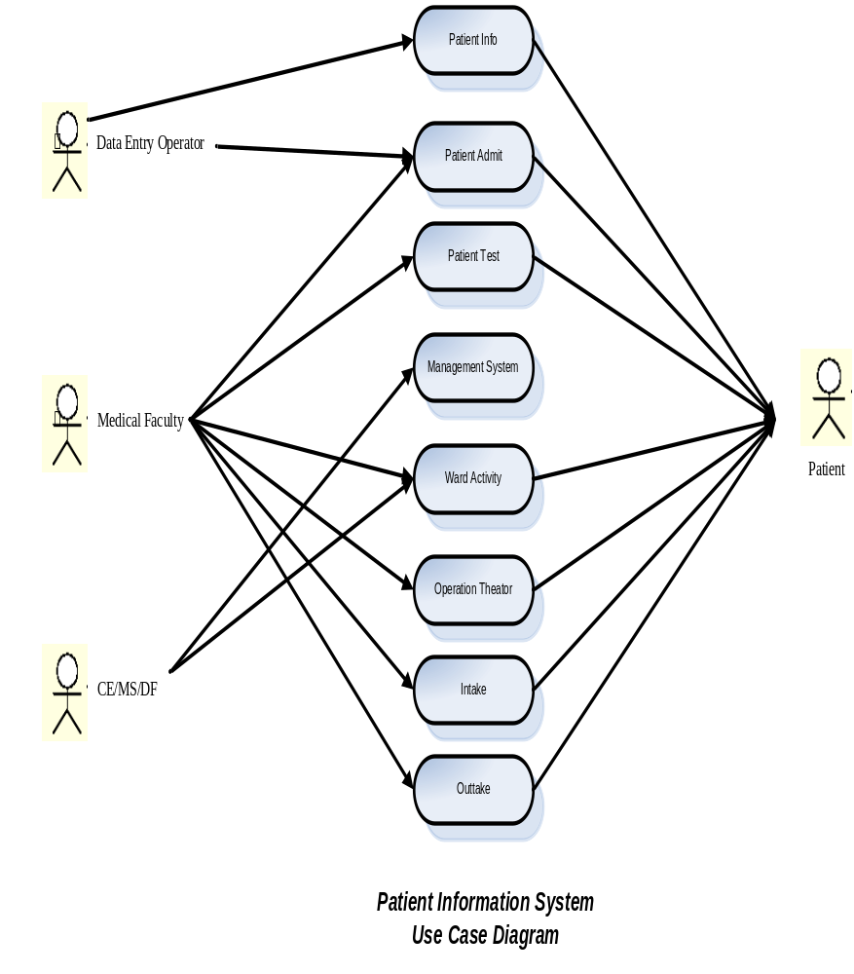

USE CASES

UC01 – Generate OPD Slip

Use Case | Generate Slip
Actors | Patient(initiator), OPD In charge(Primary)
Type | Primary
Description | Patient comes to hospital OPD. He is then asked for his name by the OPD in charge. The OPD in charge records the patient’s information and generate an OPD slip that contains patient information and concern doctor information. The patient then leaves the OPD counter and goes to specific OPD.

UC02 – General OPD Treatment

Use Case | OPD Treatment
Actors | Doctor
Type | Primary
Description | Patient comes to specific OPD after getting the OPD slip. In the OPD the patient is treated by the specific TMO (Training Medical Officer). The doctor will advise some medicine or will advise some test to find the root cause of the disease. If the disease is severing, the patient may be admitted in Ward. if the disease is not sever, the patient will leave the hospital after the doctor advised medicines.

UC03 – Specialist OPD Treatment

Use Case | Specialist OPD Treatment
Actors | Doctor
Type | Primary
Description | Patient comes to specific OPD after getting the OPD slip. In the OPD the patient is treated by the TMO (training medical officer). If the TMO can’t diagnose the disease, he may refer the patient to Specialist OPD where the Patient is treated by Specialist doctor. The doctor will advise some medicine to the patient or will advise some test to find the root cause of the disease. After advising the medicine ht patient will leave the hospital. If the disease is severing, the patient may be admitted in a Ward.

UC04 – Patient Admission

Use Case | Patient Admission
Actors | Doctor
Type | Primary
Description | The TMO in OPD or specialist doctor in specialist OPD may decide to admit patient in ward if the disease is sever. when a patient is admitted in ward his complete information like patient#, patient name, age, sex, date of admission, bed # and referring OPd information are stored.

UC05 – Daily Activities

Use Case | Daily Ward Activities
Actors | Doctor
Type | Primary
Description | When a patient is admitted in ward, then daily ward activities starts. The daily ward activities include recording patient temperature and patient blood pressure information. This information indicates the status of patient.

UC06 – Patient Intake
Use Case | Patient Intake
Actors | Patient
Type | Primary
Description | When a patient is admitted in a ward, then the doctor will advised some medicines that the patient will use on daily basis. The information about the medicine, its type, its quantity and root of the medicines information are recorded.
UC07 – Patient Output

Use Case | Patient output
Actors | Patient
Type | Primary
Description | When a patient is admitted in ward, the doctors need various information for the diagnoses of disease and that’s why they want information about patient output i.e. Urine, Stool and Vomiting. The doctors need this information along with timing of each output and number of timing of each output. This information helps the doctor to diagnose the disease.

UC08 – Patient test

Use Case | Patient test
Actors | Patient, Lab In charge(Primary)
Type | Primary
Description | A TMO in OPD, Specialist doctor in Specialist OPD or a doctor in ward may advise test for a patient to find the root cause of the disease. So the doctor specifies the test type and test name. The lab in charge conducts the test and the information about the patient; patient test and the final result of the test are recorded.

UC09 – Patient Operation

Use Case | Patient Operation.
Actors | Doctor(primary),patient(offstage).OT(Supporting)
Type | Primary
Description | Only admitted patients can be operated and the operation is advised by the doctor. If an OPD patient is needed to be operated, he first must be admitted in a ward. The information about the patient, the doctor who advised the operation, the operation information, the doctor who operated the patient and information about the various assistants that assist the doctor in operation is recorded.
UC010 – Patient Discharge

Use Case | Patient Discharge
Actors | Doctor(Primary), Patient(Offstage)
Type | Primary
Description | At some stage of treatment the concern doctor may decide to discharge the patient according to the status of the patient. For this purpose the patient is discharged and a discharge slip is given to the patient. This discharge slip contains information about the patient, the doctor who decided to discharge the patient and any medicines the doctor advised for home treatment. .

UC10 – Patient Death

Use Case | Patient Death
Actors | Doctor(Primary), Patient(Offstage)
Type | Primary
Description | At any stage of treatment the admitted patient may get expired and the patient file gets closed. Whenever a patient get expired then a patient death report or death slip is generated by the doctor who treated the patient. This slip is generated along with information of patient and cause of the death.

Ranking

- Patient Info
- Patient Admit
- Patient Test
- Management System
- Ward Activity
- Operation Theater
- Patient Intake
- Patient Outtake

  - Significant Impact (Architecture)
  - Significant Info. Reports
  - Risky, Time critical or Complex
  - New Research Oriented
  - Basic Primary Process
  - Support Increased Revenue /Decreased Costs

Use Case | a | b | c | d | e | f | Sum
1 | 7 | 9 | 5 | 3 | 9 | 1 | 34
2 | 7 | 7 | 5 | 3 | 7 | 1 | 30
3 | 7 | 7 | 3 | 2 | 3 | 1 | 23
4 | 9 | 9 | 9 | 9 | 7 | 9 | 52
5 | 7 | 9 | 5 | 3 | 9 | 1 | 34
6 | 9 | 9 | 9 | 7 | 7 | 9 | 48
7 | 7 | 9 | 5 | 3 | 9 | 1 | 34
8 | 7 | 9 | 5 | 3 | 9 | 1 | 34

Expanded Use Cases

Expanded Use Cases

UC – Generate OPD Slip

Use Case: | Generate OPD Slip
Actors: | Patient(initiator), OPD In charge(Primary)
Purpose | To Generate OPD Slip to the Patient
Overview | Patient comes to hospital OPD. He is then asked for his name by the OPD in charge. The OPD in charge records the patient’s information and generate an OPD slip that contains patient information and concern doctor information. The patient then leaves the OPD counter and goes to specific OPD.
Type | Primary
Cross References | *Use cases: Data Entry Operator must have completed “Patient Info’.

Typical Course of Events
Actor Action | System Response
1. This use case begins when a patient come to the OPD (Out Patient Department).
2. Data Entry Operator enters the patient information. | 3. System checks for the patient information in the previous record.
 | 4: System provides the unique ID to the patient.
 | 5. System Generate the OPD Slip with the patient Info and Patient ID.
6. Data Entry Operator gives the OPD Slip with hospital file to the patient.
Alternate Courses
4: System finds that patient record already exists.
5: System assign the patient with the previous ID recorded against his info.

UC – Patient Admission

Use Case | Patient Admission
Actors | Doctor
Purpose | To admit patient in the hospital.
Overview | The TMO in OPD or specialist doctor in specialist OPD may decide to admit patient in ward if the disease is sever. when a patient is admitted in ward his complete information like patient#, patient name, age, sex, date of admission, bed # and referring OPd information are stored.
Type | Primary

Cross References | *Use cases: Patient Admission must have complete “Patient Info’.

Typical Course of Events
Actor Action | System Response
1. This use case begins when a patient gets advice from the TMO (Training Medical Officer) to admit in the hospital.
2. TMO gives the patient a permit letter for the admission.
3. Patient submits permit letter and Info (Unique ID) to the entry operator.
 | 4. System checks for wards and empty beds.
5: Entry operator gives bed no. and ward no. to the patient. | 6: System stores the complete patient info with the ward no. and bed no. and advice doctor name and ID.
Alternative Courses
4: System results no empty wards with beds for the patient admission.

UC – Daily Activities

Use Case | Daily Ward Activities
Actors | Doctor
Purpose | To generate daily ward activity.
Overview | When a patient is admitted in ward, then daily ward activities starts. The daily ward activities include recording patient temperature and patient blood pressure information. This information indicates the status of patient.
Type | Primary
Cross References | .

Typical Course of Events
Actor Action | System Response
1. This use case begins when all medical staff daily attends the patients in the wards.
2. Medical staff writes report and daily activities including recording of patient temperature, blood pressure report, Drips, e.t.c.
3. Advice patient doctors daily check the report. | 4. System records all reports against all patients.
Alternate Courses
4: The reports of the discharged patient are removed from the record.

UC – Patient test
Use Case | Patient test
Actors | Patient, Lab In charge(Primary)
Purpose | To take patient test information.
Overview | A TMO in OPD, Specialist doctor in Specialist OPD or a doctor in ward may advise test for a patient to find the root cause of the disease. So the doctor specifies the test type and test name. The lab in charge conducts the test and the information about the patient; patient test and the final result of the test are recorded.
Type | Primary
Cross References | .

Typical Course of Events
Actor Action | System Response
1. This use case begins when a patient test is taken.
2. Entry Operator gives OPD Slip with test IDs.
3. Patient Submit Test IDs with his OPD slip to the Lab In charge.
4. Lab In charge enters the patient information with Test ID and advice doctor ID. | 5. System stores the patient information with Test IDs and advised doctor name.
6: Medical Lab In charge takes the test. | 7: System generates the issuance slip.
7: Patient Submit the test fee. | 8: System makes the test status true
 | 9: System prints all the test information with patient info.
Alternate Courses
5: System contains already same test ID with the same patient ID.
9: System prints all the previous test information with the new one.
UC – Patient Operation

Use Case | Patient Operation.
Actors | Doctor(primary),patient(offstage).OT(Supporting)
Purpose | To generate information about patient information.
Overview | Only admitted patients can be operated and the operation is advised by the doctor. If an OPD patient is needed to be operated, he first must be admitted in a ward. The information about the patient, the doctor who advised the operation, the operation information, the doctor who operated the patient and information about the various assistants that assist the doctor in operation is recorded.
Type | Primary
Cross References | .

Typical Course of Events

Actor Action | System Response
1. This use case begins when the patient is taken in operation theater for an operation. | 2: System stores complete patient information with medical faculty ID who is attending the operation.
3. Medical staff purchase all the operation equipment e.g. drip, glucose, e.t.c.
4. Operation related activity is noted during the operations and entered in the record. | 5. System records all the related reports which were taken during the operation.
6: Operation report is given to the attended medical faculty.
Alternative Courses

3: All related medical equipment already contains with the hospital.

UC – Patient Discharge

Use Case | Patient Discharge
Actors | Doctor(Primary), Patient(Offstage)
Purpose | To take related information of discharge patient.
Overview | At some stage of treatment the concern doctor may decide to discharge the patient according to the status of the patient. For this purpose the patient is discharged and a discharge slip is given to the patient. This discharge slip contains information about the patient, the doctor who decided to discharge the patient and any medicines the doctor advised for home treatment. .
Type | Primary
Cross References

Typical Course of Events
Actor Action | System Response
1. This use case begins when the patient is discharged from the hospital.
2: The entry operator checks for the patient dues related to the hospital charges. | 3: System generates the hospital charges slip.
3. The discharged patient clears all dues. | 5. System provides the fitness certificate.  6: System temporary delete discharge patient records from the current system.  7: System stores patient record in all discharged history.
Alternative Courses

5: System provides death certificate in case of death.

UC – Patient Death

Use Case | Patient Death
Actors | Doctor(Primary), Patient(Offstage)
Purpose | To generate information of expire patient.
Description | At any stage of treatment the admitted patient may get expired and the patient file gets closed. Whenever a patient get expired then a patient death report or death slip is generated by the doctor who treated the patient. This slip is generated along with information of patient and cause of the death.
Type | Primary
Cross References | .

Typical Course of Events
Actor Action | System Response
1. This use case begins when the patient expires. | 2. System generate death certificate with death causes.
3. The medical faculty member signs the death certificate and checks the cause of death. | 4: System deletes the record of the expire patient and stores it in death records.
Alternative Courses

2: System don’t generate death certificate if there is no patient record in OPD.

Domain Model

Domain Model

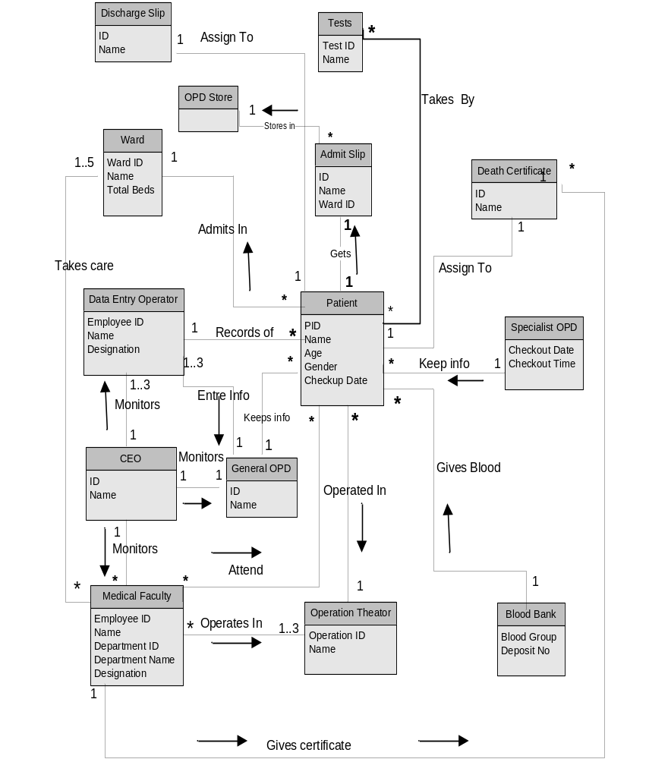

Concept Category List
Concept Category | Concepts
Physical or tangible objects | - OPD Slip  - Test Slip  - Discharge Slip  - Death Certificate
Specifications, Designs or Description of things | - Symptoms  - Diagnosis  - Medicines
Places | - Wards  - General OPD  - Special OPD  - Operation Theater
Transactions | - Operation  - Patient Admission  - Patient Discharge
Transaction line items | - Operation observations  - Ward observations
Roles of people | - Data Entry Operator  - Medical Faculty  - Patient  - CEO
Containers of other things | OPD Store
Things in a container | Admit Slip
Other computer or Electro-mechanical systems external to our system | Not Applicable
Abstract Noun concepts | Not Applicable
Organizations | Hospital
Events | - Generate OPD Report  - Generate Operation Report  - Generate Intake/Outtake Report  - Generate Death Report  - Generate Discharge Report
Processes | - Admission  - Operation  - Treatment  - Patient History  - Intake History  - Outtake History
Rules and Policies | Verification of Patients
Catalogs | Not Applicable
Records of finance work, contracts, legal matters | Not Applicable
Financial Instruments and services | Not Applicable
Manuals, books | Not Applicable

Applying the Associations Checklist

Category | Examples
A is physical part of B | Patient – Discharge Slip  Patient – Death Certificate  Patient – Admit Slip
A is a logical part of B | - Pre-operative Test-Operation  - Post operative Test-Operation  - Pre-operative Test-Diagnosis
A is physically contained in B | Admit Slip – OPD Store
A is logically contained in B | Admit Slip – Data Entry Operator
A is a description of B | Employee ID- Data Entry Operator  Employee ID – Medical Faulty  Patient ID -- Patient  Test ID -- Test
A is a line item of a transaction B | Data Entry Operator – Patient Info
A is logged/recorded in B | Admit Slip – OPD Store
A is a member of B | Data Entry Operator – General OPD  Medical Faculty– Ward  Medical Faculty-- Operation
A is an organizational subunit of B | Ward –General OPD  Operation – Special OPD
A uses or manages B | Medical Faculty – Ward  Medical Faculty – General OPD  Medical Faculty – Specialist OPD  Medical Faculty – Operation Theater  Medical Faculty – Blood Bank
A communicates with B | Patient – Medical Faculty  Patient – Data Entry Operator  Medical Faculty – Data Entry Operator
A is related to a transaction B | Not Applicable
A is transaction related to another transaction B | Not applicable
A is next to B | Patient Admission – Diagnosis  Patient Admission – Operation  Patient Test -- Diagnosis
A is owned by B | Not Applicable

System Sequence Diagram

Start Up
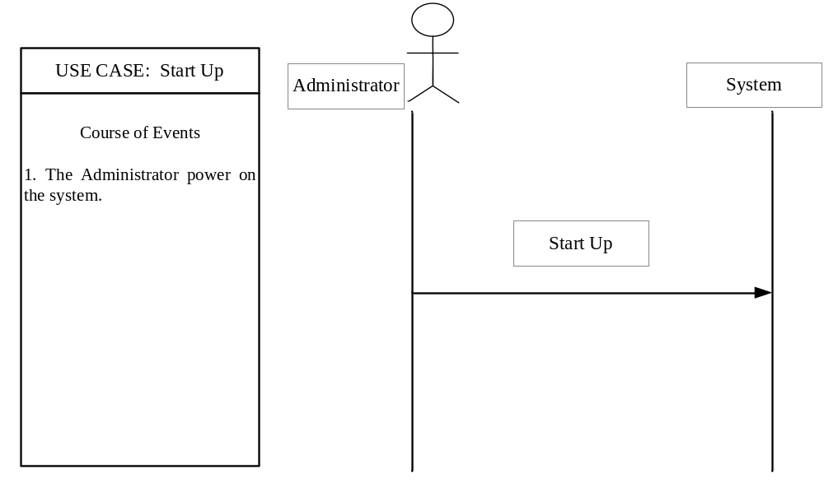

Login 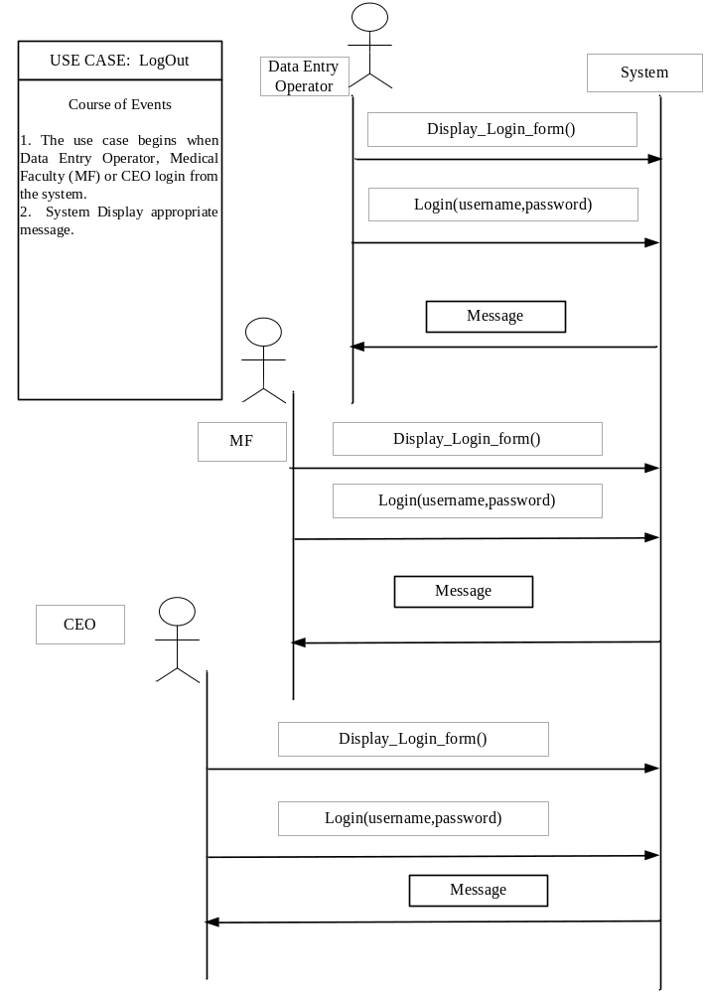
Contract CO-01

Name | Display_Login_Form()
Responsibility | To display the login form, on request.
Type | Interface level
Cross-Reference | SSD-02
Notes | Provide hyperlink on software main page.
Exceptions | NIL
Output | NIL
Pre-conditions | - System has been start up by the System Administrator
Post conditions | Form is Displayed.

Contract CO – 02

Name: | Login (username: text, password: text)
Responsibilities: | To Authenticate and then log the user into the system
Type: | Software Class
Cross References | SSD 02, UC03
Notes: | Passwords will be encrypted and then stored in the database
Exceptions: | User enters invalid login name or password.
Output: | Nil
Pre-conditions: | Nil
Post-conditions:
- Instance of ActiveUser was created.
- User was associated with active account.
- Account.Active was set to true.

LOGOUT
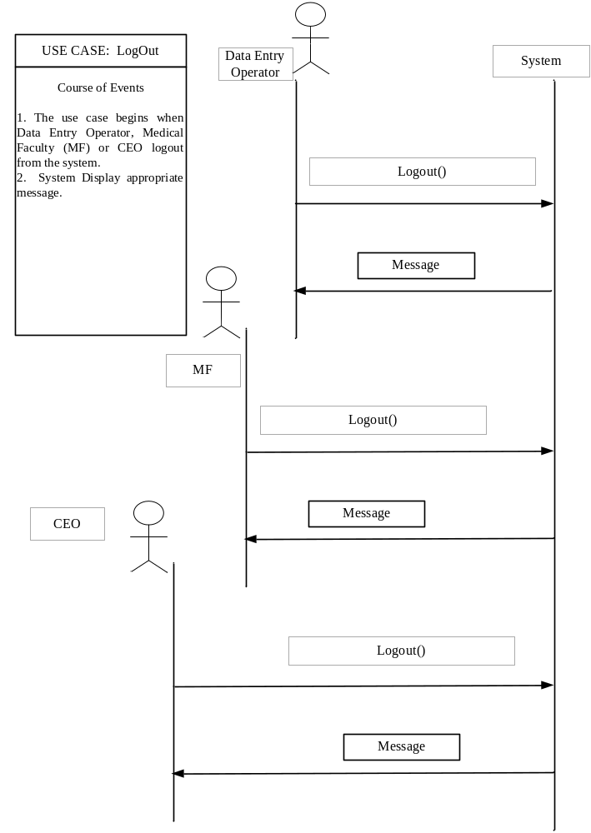
Contract CO - 03

Name: | LogOut ()
Responsibilities: | To successfully log the user out of the system
Type: | Software Class
Cross References | SSD 03, UC04
Notes: | Nil.
Exceptions: | Nil.
Output: | Nil
Pre-conditions: | - User had logged in
Post-conditions:
- Instance of ActiveUser is deleted.
- Association of User and Account is broken.
- Account.Active was set to false.

Record Patient Information
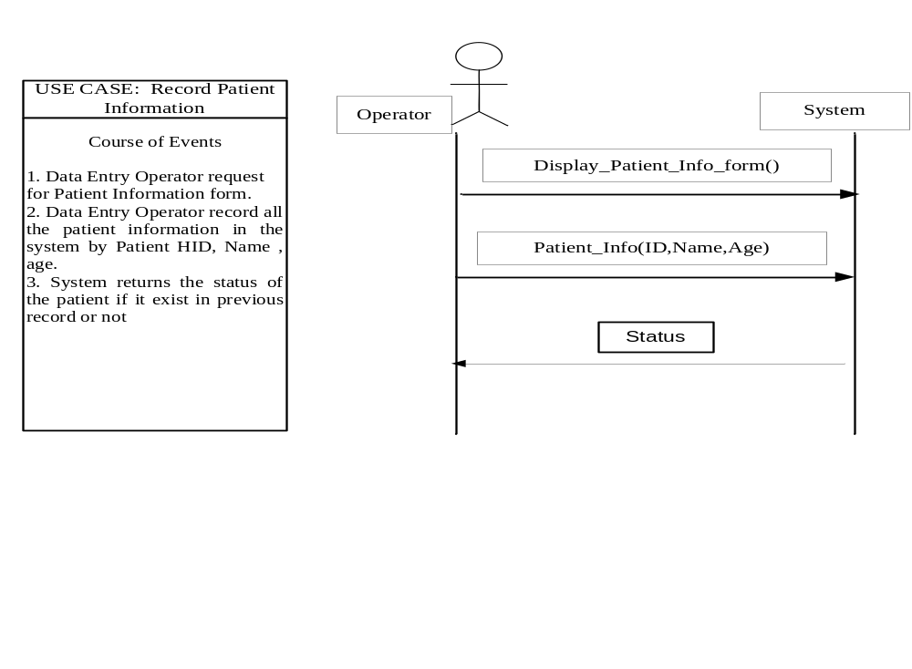
Contract CO 04

Name: | Display_Patient_Info _Form ()
Responsibilities: | To Display the Patient Info form, on request.
Type: | Interface
Cross References | SSD 04
Notes: | Provide hyperlink and button on main page.
Exceptions: | Nil
Output: | Nil
Pre-conditions: | - The requesting employee had logged into the system
Post-conditions:
Form is Displayed.

Contract CO – 05

Name: | Patient_Info (ID.text,Name.text,Age.number)
Responsibilities: | To Enter the patient info and record to the database of the system.
Type: | Software Class.
Cross References | SSD 04
Notes: | Nil
Exceptions: | Record of patient already exists in the system.
Output: | Status of the patient.
Pre-conditions: | - The requesting employee had logged into the system
Post-conditions:
- Instance of a Patient was created.
- Patient info stored in the database table.

Generate OPD Slip
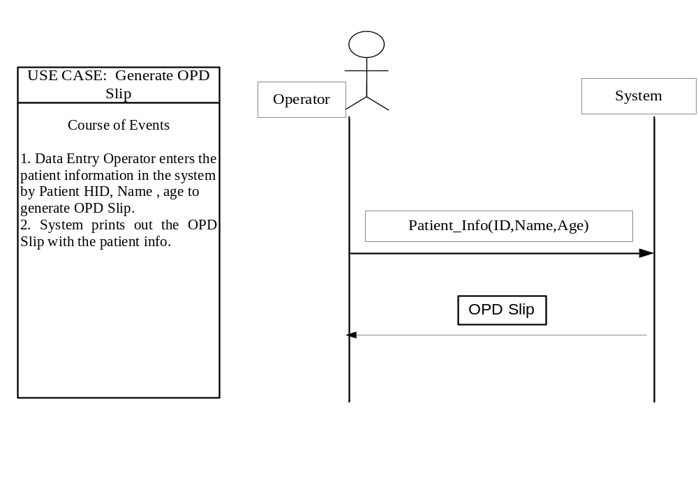Contract CO – 06

Name: | Patient_Info (ID.text,Name.text,Age.number)
Responsibilities: | To Enter the patient info to generate OPD Slip for patient .
Type: | Software Class.
Cross References | SSD 05
Notes: | Nil
Exceptions: | Record of patient does not exist in the system.
Output: | OPD Slip
Pre-conditions: | - The requesting employee had logged into the system  - The patient info already store in the database.
Post-conditions:
- Patient info OPD slip printed.

Patient Admission
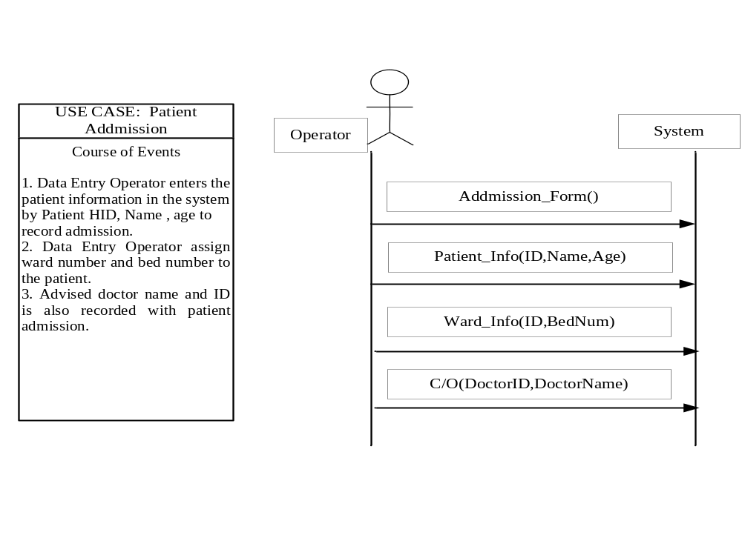 Contract CO – 07

Name: | Addmission_Form()
Responsibilities: | Admission of the patient in the hospital.
Type: | Interface.
Cross References | SSD 06
Notes: | Nil
Exceptions: | Record of patient does not exist in the system.
Output: | Admission form
Pre-conditions: | - The requesting employee had logged into the system
Post-conditions:
- Admission form displayed.

Contract CO – 08

Name: | Ward_Info (ID.number,Name.text)
Responsibilities: | To Enter the Ward info for the admission in the hospital.
Type: | Software Class.
Cross References | SSD 06
Notes: | Nil
Exceptions: | Ward number is incorrect.
Output: | Nil
Pre-conditions: | - The ward info (number and name) is valid.
Post-conditions:
- Nil.

Contract CO – 09

Name: | Patient_Info (ID.text,Name.text,Age.number)
Responsibilities: | To Enter the patient info to get the admission in the hospital.
Type: | Software Class.
Cross References | SSD 06
Notes: | Nil
Exceptions: | Record of patient does not exist in the system.
Output: | OPD Slip
Pre-conditions: | - The requesting employee had logged into the system  - The patient info already store in the database.
Post-conditions:
- Nil

Contract CO – 10

Name: | C/O(DoctorID.number,DoctorName.text)
Responsibilities: | To Enter the doctor info who c/o the patient for the admission
Type: | Software Class.
Cross References | SSD 06
Notes: | Nil
Exceptions: | Record of doctor does not exist in the system.
Output: | Nil
Pre-conditions: | - The requesting employee had logged into the system  - The doctor info already exists.
Post-conditions:
- Instance of a Doctor was created.
- Doctor info retrieve in the database table.

Generate Daily Report
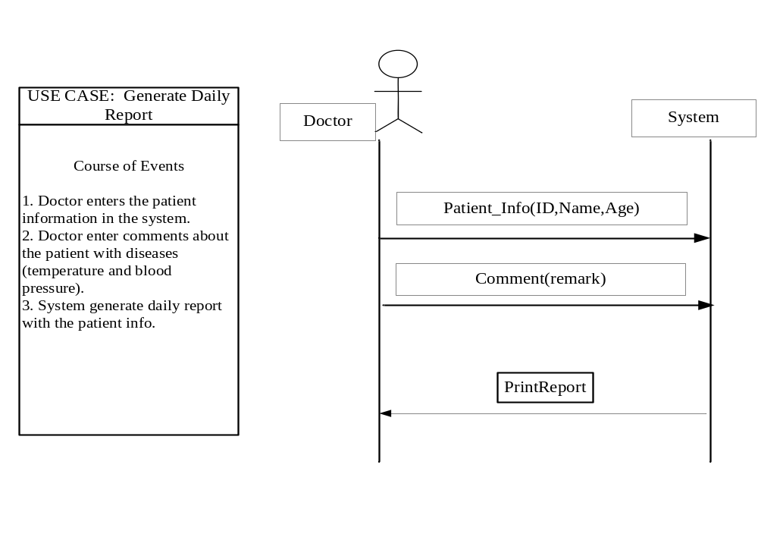
Contract CO – 11

Name: | Patient_Info (ID.text,Name.text,Age.number)
Responsibilities: | To Enter the patient info to get daily report.
Type: | Software Class.
Cross References | SSD 07
Notes: | Nil
Exceptions: | Record of patient does not exist in the system.
Output: | Daily Report
Pre-conditions: | - The requesting doctor had logged into the system  - The patient info already store in the database.
Post-conditions:
- Nil

Contract CO – 12

Name: | Comment(remard.txt)
Responsibilities: | To Enter the comments for the patient.
Type: | Software Class.
Cross References | SSD 07
Notes: | Nil
Exceptions: | Nil
Output: | Daily Report
Pre-conditions: | Nil
Post-conditions:
- Nil

Patient Intake Chart
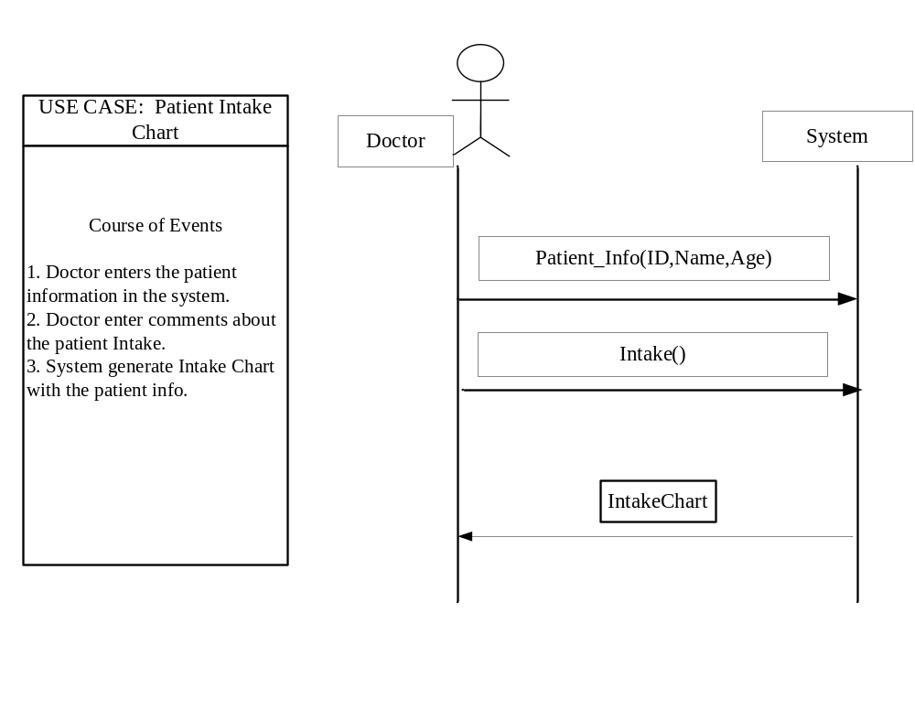Contract CO – 13

Name: | Patient_Info (ID.text,Name.text,Age.number)
Responsibilities: | To Enter the patient info to get intake chart.
Type: | Software Class.
Cross References | SSD 08
Notes: | Nil
Exceptions: | Record of patient does not exist in the system.
Output: | Intake Chart
Pre-conditions: | - The requesting doctor had logged into the system  - The patient info already store in the database.
Post-conditions:
Nil
Patient Outtake Chart
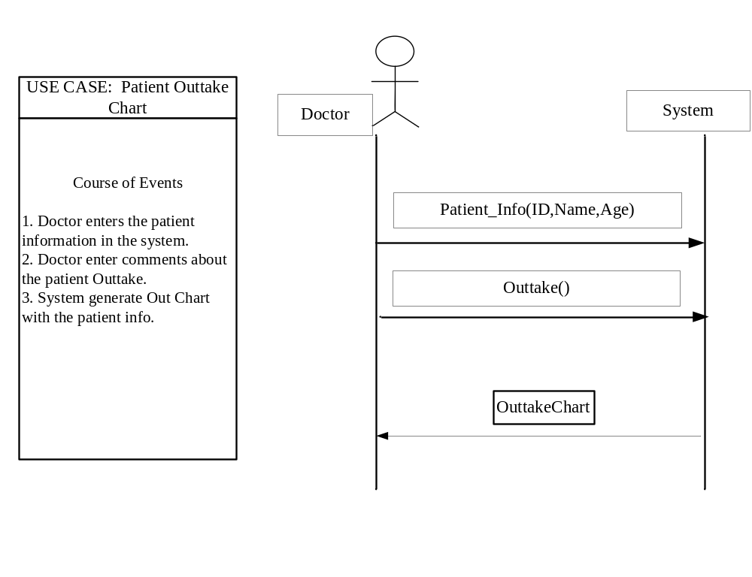
Contract CO – 14

Name: | Patient_Info (ID.text,Name.text,Age.number)
Responsibilities: | To Enter the patient info to get outtake chart.
Type: | Software Class.
Cross References | SSD 09
Notes: | Nil
Exceptions: | Record of patient does not exist in the system.
Output: | Outtake Chart
Pre-conditions: | - The requesting doctor had logged into the system  - The patient info already store in the database.
Post-conditions:
- Nil

Patient Test
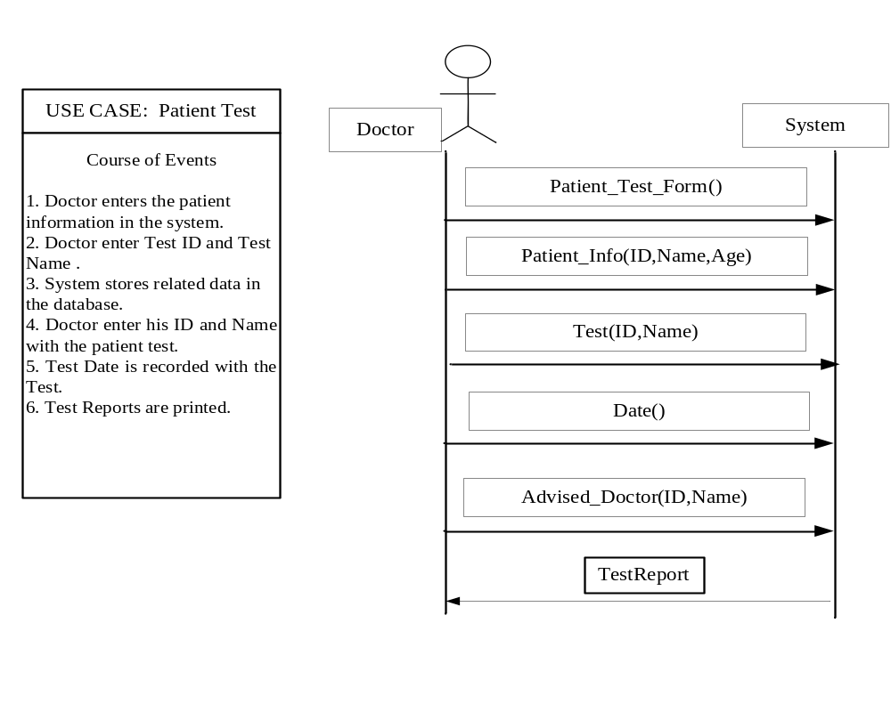Contract CO – 15

Name: | Patient_Test_Form()
Responsibilities: | To request for the patient test form
Type: | Interface.
Cross References | SSD 10
Notes: | Nil
Exceptions: | Nil
Output: | Nil
Pre-conditions: | Nil
Post-conditions:
Test Form Display.
Contract CO – 16

Name: | Patient_Info (ID.text,Name.text,Age.number)
Responsibilities: | To Enter the patient info for tests.
Type: | Software Class.
Cross References | SSD 10
Notes: | Nil
Exceptions: | Record of patient does not exist in the system.
Output: | Nil
Pre-conditions: | - The requesting doctor had logged into the system  - The patient info already store in the database.
Post-conditions:
- Nil

Contract CO – 17

Name: | Test (ID.number,Name.text)
Responsibilities: | To Enter the Test ID and name for the test.
Type: | Software Class.
Cross References | SSD 10
Notes: | Nil
Exceptions: | Test ID and name is invalid.
Output: | Nil
Pre-conditions: | - The requesting doctor had logged into the system  - The Test info already store in the database.
Post-conditions:
- Instance of Test is created
- Test Info retrieve from the database.

Contract CO – 18

Name: | Date()
Responsibilities: | To Enter the date with the patient test.
Type: | Software Class.
Cross References | SSD 10
Notes: | Nil
Exceptions: | Nil.
Output: | Nil
Pre-conditions: | Nil
Post-conditions:
- Nil

Contract CO – 19

Name: | Advised_Doctor (ID.text,Name.text)
Responsibilities: | To Enter the Advised doctor info for test.
Type: | Software Class.
Cross References | SSD 10
Notes: | Nil
Exceptions: | Record of Doctor does not exist in the system.
Output: | Nil
Pre-conditions: | - The Doctor info already store in the database.
Post-conditions:
- Instance of Doctor was created.
- Info of advised doctor was retrieve from database.

Patient Operation
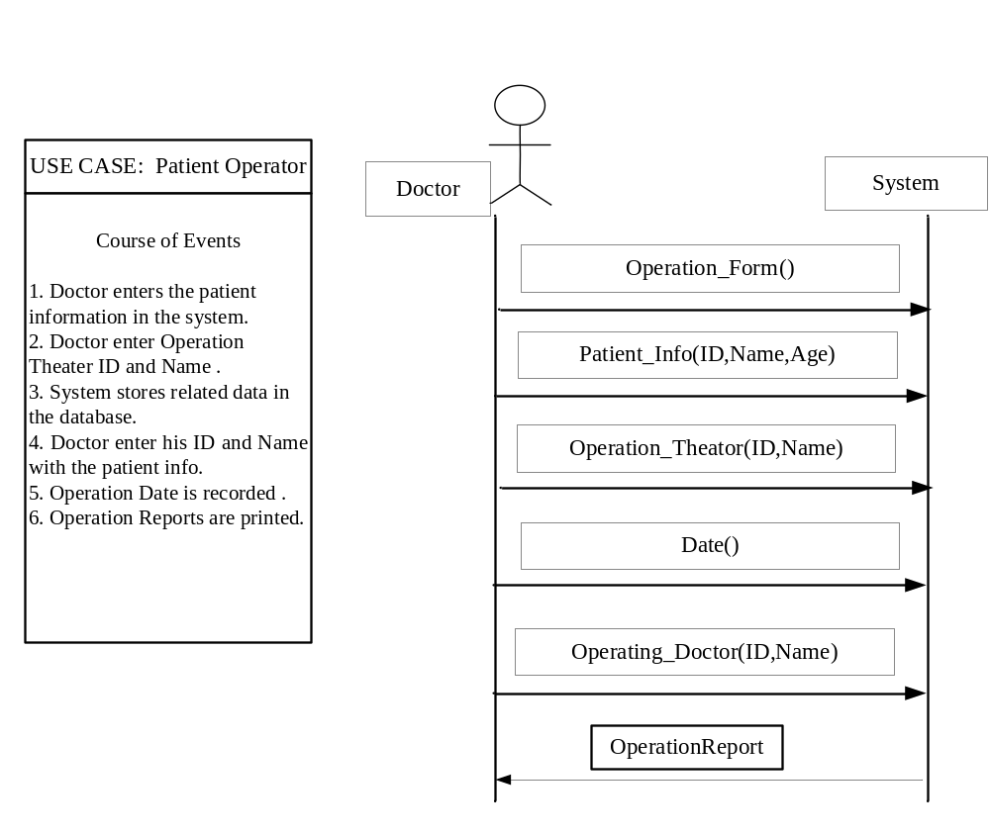
Contract CO – 20

Name: | Operation_Form()
Responsibilities: | To request for the patient test form
Type: | Interface.
Cross References | SSD 11
Notes: | Nil
Exceptions: | Nil
Output: | Nil
Pre-conditions: | Doctor has logged in to the system.
Post-conditions:
Operation Form Display.

Contract CO – 21

Name: | Patient_Info (ID.text,Name.text,Age.number)
Responsibilities: | To Enter the patient info for operation
Type: | Software Class.
Cross References | SSD 11
Notes: | Nil
Exceptions: | Record of patient does not exist in the system.
Output: | Nil
Pre-conditions: | - The requesting doctor had logged into the system  - The patient info already store in the database.
Post-conditions:
- Nil

Contract CO – 22

Name: | Operation_Theater(ID.number,Name.text)
Responsibilities: | To Enter the Operation Theater ID and name for the test.
Type: | Software Class.
Cross References | SSD 11
Notes: | Nil
Exceptions: | Operation Theater ID and name is invalid.
Output: | Nil
Pre-conditions: | - The requesting doctor had logged into the system  - The Operation Theater info already store in the database.
Post-conditions:
- Instance of OT is created
- OT Info retrieve from the database.

Contract CO – 23

Name: | Date()
Responsibilities: | To Enter the date with the patient operation.
Type: | Software Class.
Cross References | SSD 11
Notes: | Nil
Exceptions: | Nil.
Output: | Nil
Pre-conditions: | Nil
Post-conditions:
- Nil

Contract CO – 24

Name: | Advised_Doctor (ID.text,Name.text)
Responsibilities: | To Enter the Advised doctor info for operation.
Type: | Software Class.
Cross References | SSD 11
Notes: | Nil
Exceptions: | Record of Doctor does not exist in the system.
Output: | Nil
Pre-conditions: | - The Doctor info already store in the database.
Post-conditions:
- Instance of Doctor was created.
- Info of advised doctor was retrieve from database.

Patient Discharge
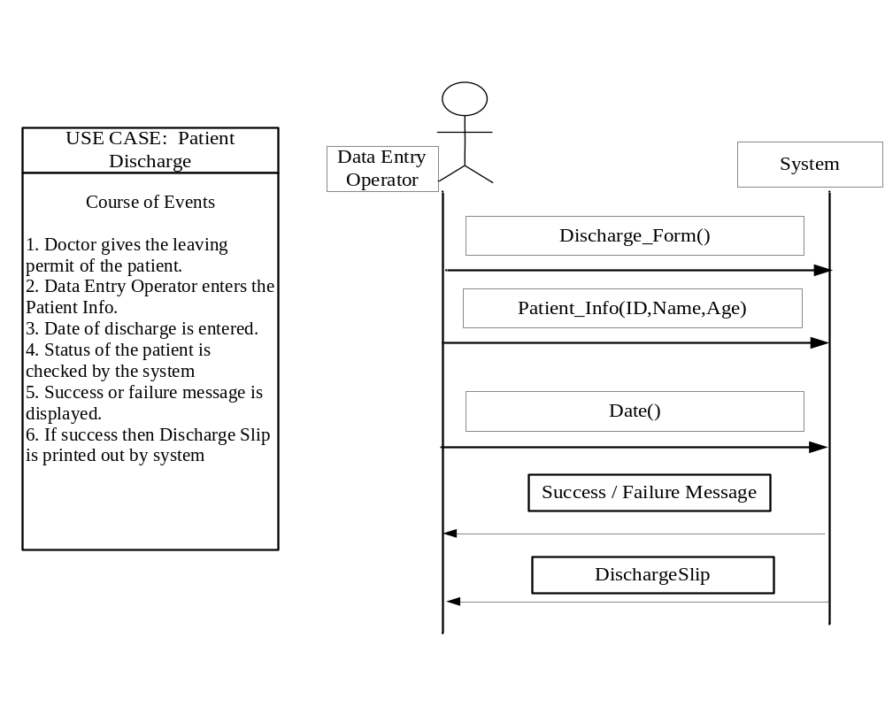
Contract CO – 25

Name: | Discharge_Form()
Responsibilities: | To request for the patient Discharge form
Type: | Interface.
Cross References | SSD 12
Notes: | Nil
Exceptions: | Nil
Output: | Nil
Pre-conditions: | Doctor has logged in to the system.
Post-conditions:
Discharge Form Display.

Contract CO – 26

Name: | Patient_Info (ID.text,Name.text,Age.number)
Responsibilities: | To Enter the patient info to discharge
Type: | Software Class.
Cross References | SSD 12
Notes: | Nil
Exceptions: | Record of patient does not exist in the system.
Output: | Nil
Pre-conditions: | - The requesting doctor had logged into the system  - The patient info already store in the database.
Post-conditions:
- Nil

Contract CO – 27

Name: | Date()
Responsibilities: | To Enter the date on which the patient discharge.
Type: | Software Class.
Cross References | SSD 12
Notes: | Nil
Exceptions: | Nil.
Output: | Nil
Pre-conditions: | Nil
Post-conditions:
- Nil

Patient Death Certificate
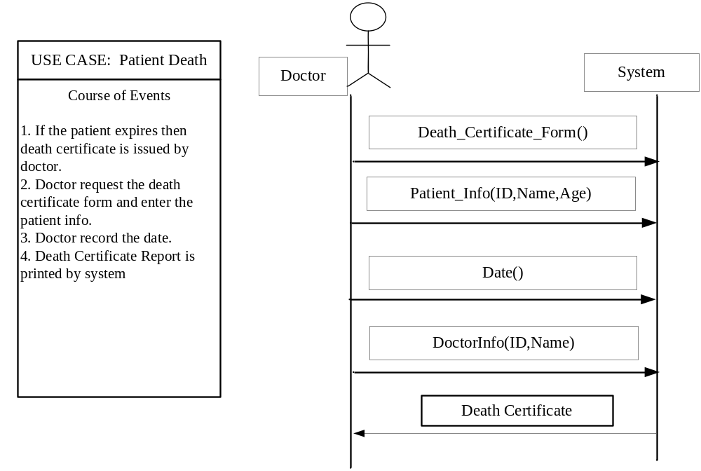

Contract CO – 28

Name: | Death_Certificate_Form()
Responsibilities: | To request for the death form
Type: | Interface.
Cross References | SSD 13
Notes: | Nil
Exceptions: | Nil
Output: | Nil
Pre-conditions: | Doctor has logged in to the system.
Post-conditions:
Death Form Display.

Contract CO – 29

Name: | Patient_Info (ID.text,Name.text,Age.number)
Responsibilities: | To Enter the patient info which death certificate is to issue
Type: | Software Class.
Cross References | SSD 13
Notes: | Nil
Exceptions: | Record of patient does not exist in the system.
Output: | Nil
Pre-conditions: | - The requesting doctor had logged into the system  - The patient info already store in the database.
Post-conditions:
- Nil

Contract CO – 30

Name: | Date()
Responsibilities: | To Enter the date on which the patient expire.
Type: | Software Class.
Cross References | SSD 13
Notes: | Nil
Exceptions: | Nil.
Output: | Nil
Pre-conditions: | Nil
Post-conditions:
- Nil

Contract CO – 31

Name: | DoctorInfo(ID.text,Name.text)
Responsibilities: | To Enter the doctor info who issue the certificate.
Type: | Software Class.
Cross References | SSD 11
Notes: | Nil
Exceptions: | Record of Doctor does not exist in the system.
Output: | Nil
Pre-conditions: | - The Doctor info already store in the database.
Post-conditions:
- Instance of Doctor was created.
- Info of advised doctor was retrieve from database.

Examines Patient Record
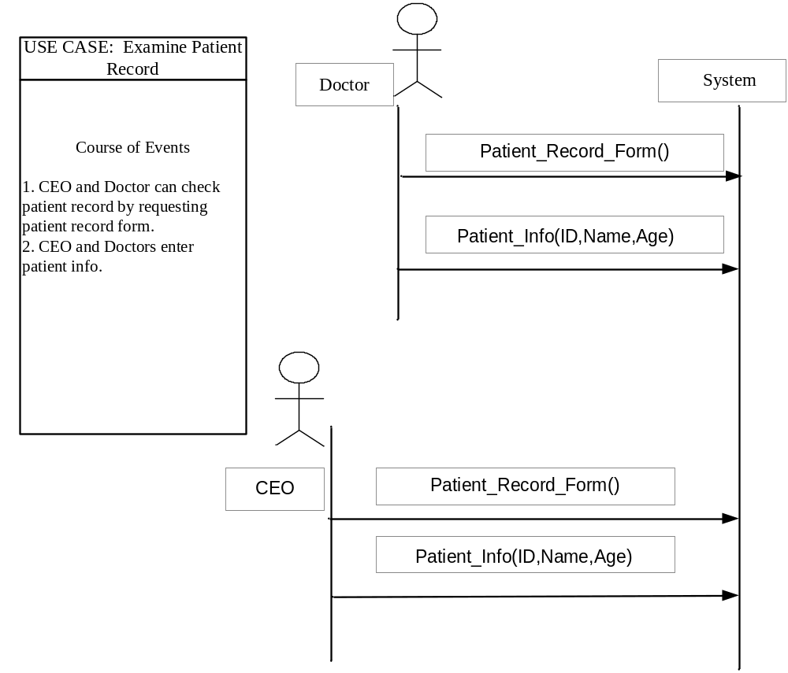
Contract CO – 32

Name: | Patient_Record_Form()
Responsibilities: | To check the record of the patient
Type: | Interface.
Cross References | SSD 14
Notes: | Nil
Exceptions: | Nil
Output: | Nil
Pre-conditions: | Doctor has logged in to the system.
Post-conditions:
Record Form Display.

Contract CO – 33

Name: | Patient_Info (ID.text,Name.text,Age.number)
Responsibilities: | To Enter the patient info to check the record
Type: | Software Class.
Cross References | SSD 14
Notes: | Nil
Exceptions: | Record of patient does not exist in the system.
Output: | Nil
Pre-conditions: | - The requesting doctor/CEO had logged into the system  - The patient info already store in the database.
Post-conditions:
- Patient Record Displayed

Real Use Cases

UC-01: Authentication

Use Case: login

Actors:
OPD In charge, Medical Faculty (MF), CEO.
Purpose:
To check user authentication.
Overview:
The organization wants only authorized users should be allowed to perform operations and for this purpose each and every user is provide with username and password.

Type: Primary and essential

Course of events:
USER LOGIN

USER NAME:

PASSWORD:

OK
CANCEL
HELP

Actor Actions: System Response:
- A user enters his name.
- A user enters his password.
- User press OK button 4) The system searches for matching
Username and Password provided to him. If matches, user is allowed to login to the system otherwise message display
“Incorrect username or password”
5) User checks the help for more details.
UC-02: Out door Patient

Use Case: OPD patient

Actors: OPD in charge, patient

Purpose: to register a patient as OPD patient

Overview: when a patient comes to a specific opd, he provide his information to opd in charge and OPD in charge register him.

Type: Primary and essential

Course of events:

PATIENT ID:

PATIENT NAME:

AGE:

GENDER:

OPD NAME:

DISTRICT:

ADD
UPDATE
FIND
Actor Actions: System Responses:
A
B
C
D
E
F
REFRESH

- This use case is initiated when a patient
Information is added. 2) System generates a unique
ID for the new patient.
3) If the user has access rights, then he
Enters patient name, patient age, patient
Gender, opd name and patient district on out
Door patient form by typing relevant information
In widget A, B, C, D, E, F.

4) The user presses the add button to get patient
registered 5) the system generate a
Message “Add Successfully” otherwise a message is displayed “enter the required information”, if any field is missing.

6) The system then generate the opd slip that contains the complete patient information.
7) If the user has update rights, then he enters
patient id.
8) The system displays complete patient information.
9) The user or doctor then selects specific fields
which he wants to update.

10) The user or doctor the presses the update button.
11) The system displays message
“Update successfully” otherwise displays message
“Enter the required information” if any field is missing.
12) The user presses the refresh button. 13) The system clears all text boxes

14) The user then enters patient ID.

15) The user presses the FIND button.
16) The system displays complete patient record if exist otherwise displays message “no record found”.

UC-03: Specialist outdoor patient

Use case: Specialist Opd patient

Actors: Medical Faculty (Doctor), patient

Purpose: To provide treatment to a patient in specialist opd.

Overview: When a patient comes to a specific opd, then the concerned doctor checks.
If case is serious and the doctor can’t diagnose the disease, then he refers the patient to specific OPD.

Type: Primary and essential

Course of events:

PATIENT ID:

PATIENT NAME:

OPD NAME:

DOCTOR:

DISEASE:

DATE:

TIME:

MEDICINES:

A
B
C
D
E
F
ADD
UPDATE
FIND
REFRESH
G
H

Actor Actions: System Response:

- This use case is initiated when a patient
is to be registered as specialist opd patient. 2) The system tracks login and checks if the login has rights to register patient as specialist opd patient

3) If he has the rights, specialist opd form is opened.
4) Then he enters the patient ID.
5) The system displays patient name, opd name, doctor name, date and time.
6) The doctor diagnoses the disease and enters
Information in the widget E.

7) Then he enters some medicines and enters
Medicines in widget H.

8) The user then presses the update button. 9) The information is saved in the data base and the system displays message “update successfully” otherwise displays message “enter required information”. If any field is missing.
10) The user enters the patient ID.

11) Then presses FIND button. 12) The system displays the patient record otherwise displays message “patient not found”.

UC-04: Patient Admission

Use case: patient admission in ward.

Actors: Medical Faculty (Doctor), patient

Purpose: To admit a patient in ward.

Overview: When patient disease is diagnosed and it is serious, then the patient is
admitted in ward for treatment and to observe his status or incase of Operation to..

Type: Primary and essential

Course of events: Actor Actions: System Response:
I

PATIENT ID:

PATIENT NAME:

AGE:

GUARDIAN:

NIC NO:

ADDRESS:

BED ASSIGNED:

WARD:

VACANT BEDS:

A
B
C
D
E
F
ADD
UPDATE
FIND
REFRESH
G
H

- this use case is initiated when a patient
is to be admitted in the ward. . 2) The system tracks login and checks if the login has rights to admit patient.

3) If he has the rights, patient admission form is opened.
4) The user enters the patient ID in widget A.
5) The system displays patient name, age address.
6) The user then enters Guardian, NIC No, bed
assigned, and ward name in the widgets D, E, G,
and H 7) The system show vacant beds in widget I.

8) The user presses ADD button to admit the
Patient.
9) The information is saved in the data base and the system displays message “patient admitted successfully” otherwise displays message “enter required information”. If any field is missing.
10) The user press refresh button to update or
To Find patient information.

11) The user enters the patient ID in widget A.

12) Then presses FIND button. 13) The system displays the patient record otherwise displays message “patient not found”.

14) The user select specific field and update that
fields.
15) The user presses the update button. 16) The information is saved in the data base and the system displays message “update successfully” otherwise displays message “enter required information”. If any field is missing.
UC-05: Patient treatment.

Use case: Admitted patient treatment.

Actors: Medical Faculty (Doctor), patient

Purpose: Treatment information provided to admitted patient.

Overview: when patients get admitted, then his treatment in ward starts. The doctor
advice him some medicines for a specific duration.

Type: Primary and essential

Course of events:
H

PATIENT ID:

PATIENT NAME:

WARD:

BED:

START DATE:

STOP DATE:

MEDICINE:

REMARKS:

REMARKS:

A
B
C
D
E
F
ADD
UPDATE
FIND
REFRESH
G

Widget I.
PATIENTID | NAME | WARD | BED | START DATE | STOP DATE | MEDICINE | REMARKS
Actor Actions: System Response:

- This use case is initiated when admitted patient
treatment starts. . 2) The system tracks login and checks if the login has rights to admit patient.

3) If he has the rights, patient treatment form is opened.
4) The user enters the patient ID in widget A.
5) The system displays patient name, ward, bed, and start date in widget B, C, D and E.
6) The user then enters stop date, medicines and
Remarks in widgets F, G, H.

7) The user presses ADD button. 8) The information is saved in the data base and the system displays message “information saved successfully” and display all the information in widget I, otherwise displays message “enter required information”. If any field is missing.
10) The user press refresh button.

11) The user enters the patient ID in widget A.

12) Then presses FIND button. 13) The system displays all the information in widget I.
14) The user select specific field and update that
fields.
15) The user presses the update button. 16) The information is saved in the data base and the system displays message “update successfully” otherwise displays message “enter required information”. If any field is missing.

UC-06: Patient daily report.

Use case: Admitted patient daily report.

Actors: Medical Faculty.

Purpose: To provide daily treatment report (BP and temperature) of admitted patient.

Overview: when a patient gets admitted in a ward, then his daily BP and temperature
is kept in a record.

Type: Primary and essential

Course of events:

PATIENT ID:

PATIENT NAME:

WARD:

BED:

DATE:

TIME:

PULSE:

BP:

TEMP:

COMPLAINT:

REMARKS:

A
B
C
D
E
F
G
H
I
J
ADD
UPDATE
FIND
REFRESH

Widget K.
PATIENTID | NAME | WARD | BED | DATE | TIME | PULSE | BP | TEMP | COMPLAINT

Actor Actions: System Response:

- this use case is initiated when an admitted
patient daily patient report is needed.
. 2) The system tracks login and checks if the login has rights to admit patient.

3) If he has the rights, daily report form is opened.
4) The user enters the patient ID in widget A.
5) The system displays patient name, ward name, bed #, and date in widget B, C, D and E.
6) The user then enters time, pulse, BP,
Temperature and any other
Complaint information in widgets F, G, H, I, J.

7) The user presses ADD button.
8) The information is saved in the data base and the system displays message “information saved successfully” and display all the information in widget I, otherwise displays message “enter required information”. If any field is missing.
9) The user press refresh button.

10) The user enters the patient ID in widget A.

11) Then presses FIND button. 12) The system displays all the information in widget k.

13) The user select specific field and update that
fields.

14) The user presses the update button. 15) The information is saved in the data base and the system displays message “update successfully” otherwise displays message “enter required information”. If any field is missing.

UC-07: Patient intake.

Use case: patient intake report.

Actors: Medical Faculty, patient.

Purpose: To provide information about patient intake.

Overview: when a patient gets admitted in a ward, then intake start as part of his
treatment. Intakes mainly include various medicines, injections, drops etc.

Type: Primary and essential

Course of events:

PATIENT ID:

PATIENT NAME:

WARD:

BED:

DATE:

TIME:

ROUTE:

QUANTITY:

FLIUDS:

REMARKS:

A
B
C
D
E
F
G
H
I
ADD
UPDATE
FIND
REFRESH

Widget J.
PATIENTID | NAME | WARD | BED | DATE | TIME | ROUTE | QUANTITY | FLUIDS

Actor Actions: System Response:

- this use case is initiated when an admitted
patient starts taking intake.
. 2) The system tracks login and checks if the login has rights to admit patient.

3) If he has the rights, then patient intake form is opened.
4) The user enters the patient ID in widget A.
5) The system displays patient name, ward name, and bed #, in widget B, C, and D.
6) The user then enters date, time, route, quantity
and fluid in widgets E, F, G, H, and I.

7) The user presses ADD button.
8) The information is saved in the data base and the system displays message “information saved successfully” and display all the information in widget j, otherwise displays message “enter required information”. If any field is missing.
9) The user presses refresh button.

10) The user enters the patient ID in widget A.

11) Then presses FIND button. 12) The system displays all the information in widget j otherwise displays message “patient not found.

13) The user select specific field and update that
fields.
14) The user presses the update button. 15) The information is saved in the data base and the system displays message “update successfully” otherwise displays message “enter required information”. If any field is missing.

UC-08 : Patient Outtake

Use-Case:
Patient Outtake Chart

Actor:
Medical Faculty. Patient

Purpose:
To provide information about patient output

Overview:
When a patient is admitted in a ward, then the medical faculty needs information
about patient output for different analysis and to analyze the patient status.

Type:
Primary and essential

Course of Events:

PATIENT ID:

PATIENT NAME:

WARD:

BED:

DATE:

TIME:

VOMIT:

STOOL:

URINE:

DRAINS:

REMARKS:

A
B
C
D
E
F
ADD
UPDATE
FIND
REFRESH
G
H
I
J

Widget K.
PATIENTID | NAME | WARD | BED | DATE | TIME | VOMIT | STOOL | URINE | DRAINS

Actor Action: System Response:

- This use case is initiated when an 2. The System login and checks if
admitted patient starts output. the login has rights or not.

3. If he has rights, then patient
output form is opened.

4. The user enters the patient id in 5. The System displays patient
names ward, bed in widget B,C
and D.
- The user enters date, time, vomit,
Stool, urine and Drains information
In widgets E,F,G,H,I, and J.

7. The user presses add button. 8. The system saves the
information
and displays a message
“Information saved successfully
and displays that information in
Widget k, otherwise displays
Message “Enter Required
Information”

- The user presses refresh button

- The user enters patient id and presses 11. The System displays patient
Find button. Information in widget k,
otherwise displays message
“Patient not found”

12. The user selects specific field he wants 13. The System updates the
to update and presses update button. Information and displays
Message “Updated Successfully”
otherwise displays message
“Enter Required Information”.

UC-9 : Patient Discharge

Use-Case:
Admitted Patience Discharge

Actor:
Medical Faculty.

Purpose:
To discharge an admitted patient after completing treatment.
Overview:
Whenever an admitted patient treatment is completed and the medical faculty
Are satisfied from his status, then they may decide to discharge him and he may continue the rest of treatment at home.

Type:
Primary and essential.

Course of Events:

PATIENT ID:

PATIENT NAME:

WARD:

BED:

ADMISSION DATE:

DISCHARGE DATE:

DIAGNOSIS:

HOSPITAL TREATMENT:

REMARKS:

A
B
C
D
E
ADD
UPDATE
FIND
REFRESH
G
F
H

Actor Action System Response

1. This use case is initiated when an admitted 2. The system tracks the login &
patient is discharged. checks if the logger has right
has right or not.
3. If he has rights then patient
discharge form is opened.

4. The user enters patient id in 5. The system displays patient
Widget A. Name, ward name, bed #,
and date of admission in
Widgets B, C, D and E.
6. The user enters date of discharge,
Diagnosis, hospital treatment and home
treatment information in widgets F,G,H and I.
7. The user presses the add button. 8. The system saves the
information in DB and
displays message “information
successfully”,otherwise displays
message “Enter required
information”.

9. The user presses the refresh button. 10. The system clears all text
box.
11. The user enters patient Id in widget A.
12. The user presses find submit. 13. The system displays the
patient record, otherwise
displays message “patient
not found”.
14. The user selects specific fields which
he wants to update.
15. The user presses the update button. 16. The system updates the
information and displays
the message “update
successful”, otherwise
displays the message
“Enter required information” .

CD-01 LOGIN

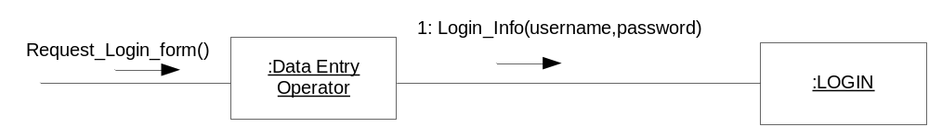

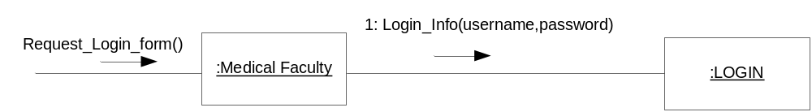

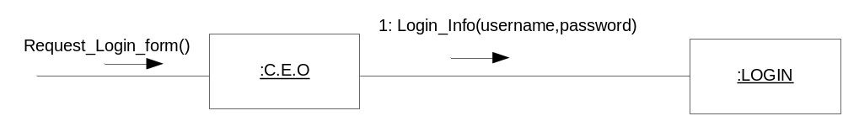

CD-02 Patient Information

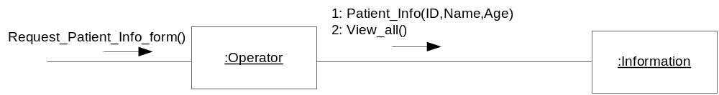

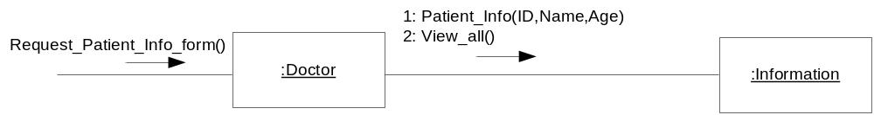

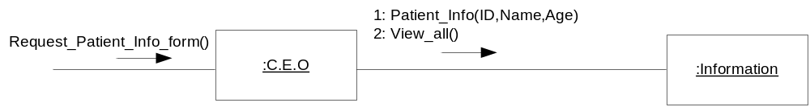

CD-03 OPD Slip

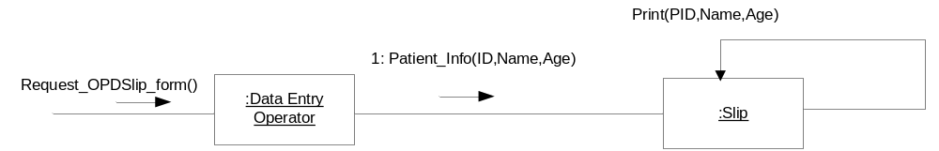

CD-04 Patient Admission

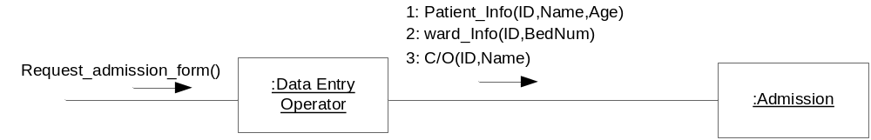

CD-05 Daily Report

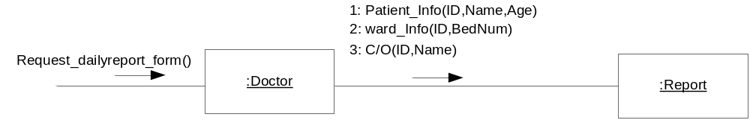

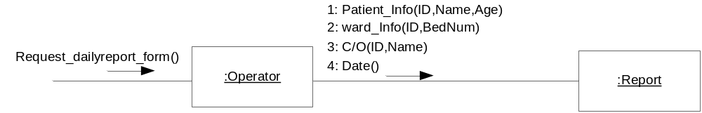

CD-06 Intake Chart

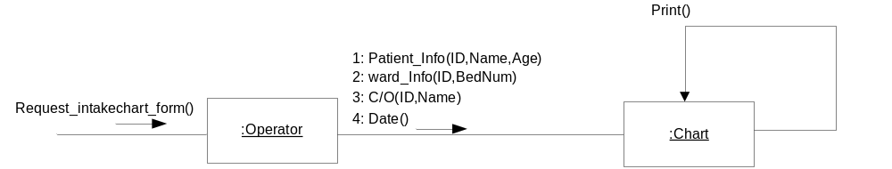

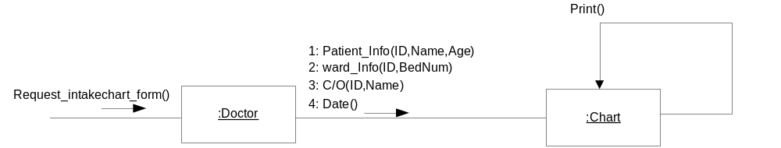

CD-07 out take Chart

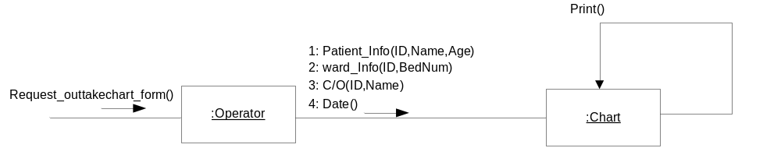

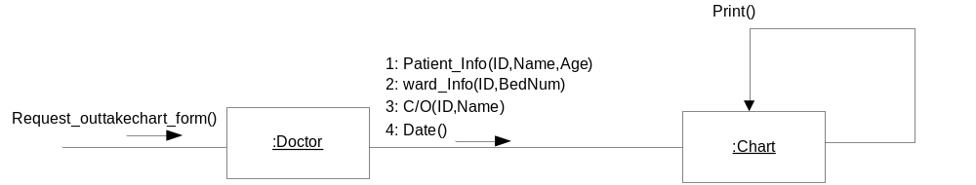

CD-08 Patient Test

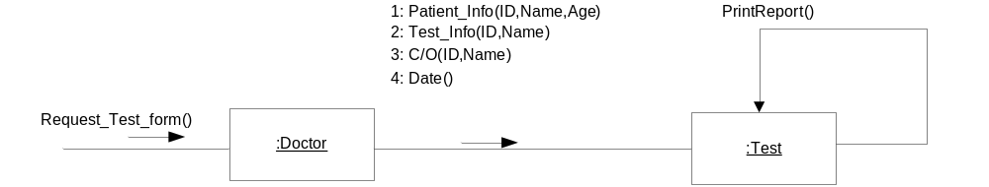

CD-09 Patient Operation

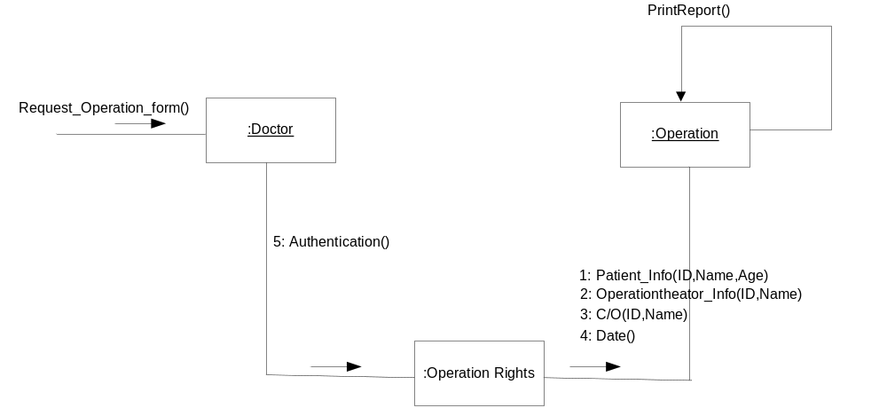

CD-10 Patient Discharge

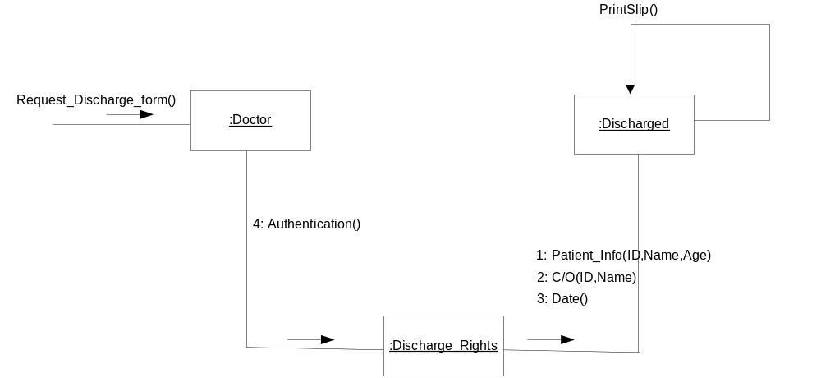

CD-11 Patient Death

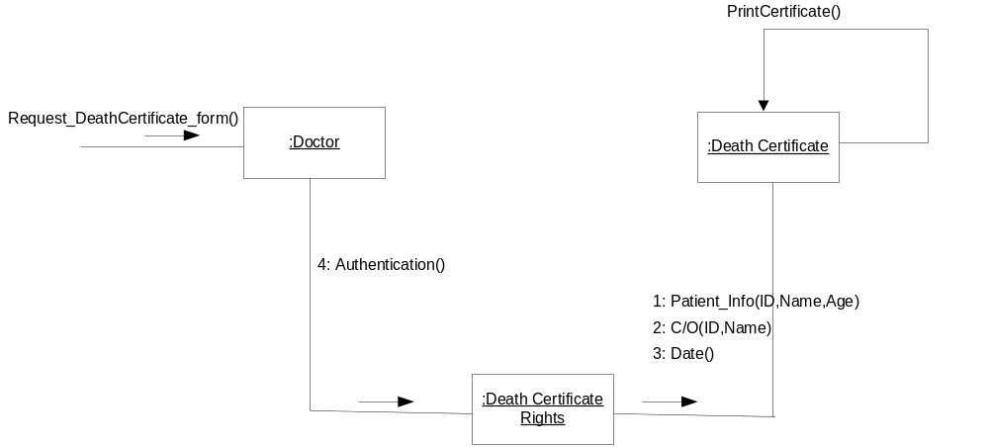

CD-12 Patient Record

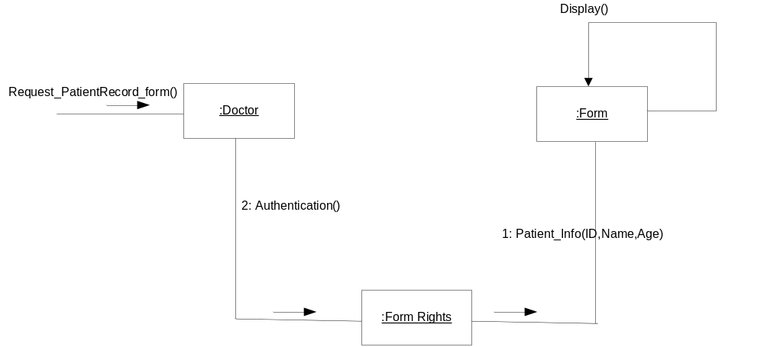

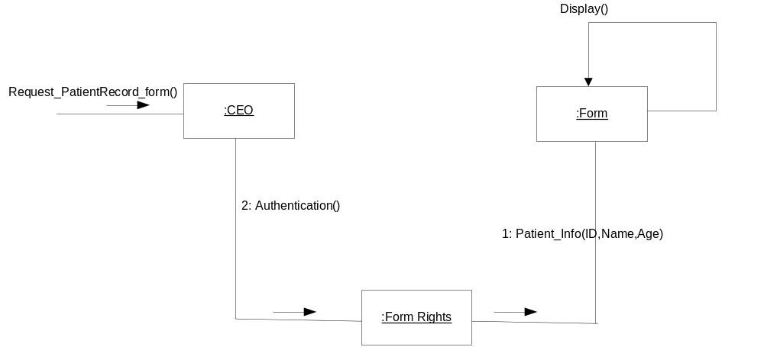

CD-13 Patient Treatment

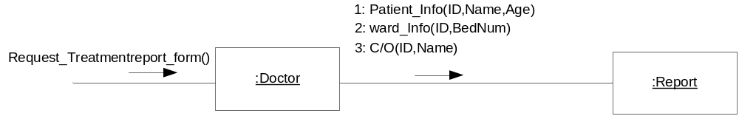
Class Diagram

